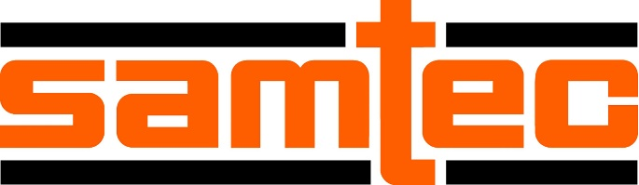

FOR IMMEDIATE RELEASE
12 September, 2023
CONTACT: Mediaroom@samtec.com

Samtec Wins Bishop European Customer Service Survey For 12th Time

Samtec has ranked #1 in the 2023 Bishop and Associates European Customer Survey of the Electronic Connector Industry. This is Samtec’s 12th consecutive win for the survey. From standard cataloged interconnects to unique high-performance designs, Samtec’s comprehensive product line supports interconnectivity needs across many industries, including industrial, military/aerospace, computer/semiconductor, automotive, datacom, medical, and instrumentation.

“Winning the Bishop and Associates European Customer Service Survey is a fantastic achievement,” said Ron Bishop, President and Founder of Bishop & Associates, “To win this survey again, in such a convoluted supply chain environment during the Covid chaos, reflects Samtec’s commitment to their Sudden Service principles.”

Sudden Service® is Samtec’s unmatched customer support through initial design, purchase, delivery, and post-sale technical support. This includes free product samples, access to extensive technical online resources (including models, data sheets, white papers, and test reports), individualized design assistance, as well as innovative online tools to help streamline the design process.

About the Survey

For this survey, Bishop & Associates surveyed electronic equipment manufacturers (OEMs), cable assembly manufacturers, contract manufacturers (CEMs), and distributors across Europe to determine how the connector industry, and selected connector manufacturers, are performing. Twenty-eight (28) connector manufacturers were named in the survey, including Phoenix Contact, Amphenol, Molex, TE Connectivity, WAGO, ept, HARTING, Harwin, Rosenberger, and Hirose.

Respondents represented a variety of market sectors, such as industrial, automotive, electric vehicle, military/government, telecom/datacom, medical, Computer/Peripheral, Test/Measurement/Instrumentation, Consumer Electronics, transportation, civil aviation, and energy. Respondents identified their job function as engineering (58%), purchasing (25%), or other (17%).

Survey Results

Samtec was ranked as the #1 connector supplier overall in Europe. The survey consisted of many categories that were used to determine this ranking. Here is a list of Samtec’s results by category:
- #1 by Engineering
- #1 by Purchasing
- #1 by OEM
- #1 by CEM/EMS
- #1 by Distributors
- #1 by Cable Assembly Companies
- Samtec ranked #1 in product quality
- #1 in meeting requested delivery date, ship date, and lead times
- #1 in technical support and expertise
- #1 with new connector design turn-around time
- #1 in outside sales support; inside sales/customer service support
- #1 in overall effectiveness in handling problems
- #1 for obtaining samples
- #1 website www.samtec.com:
  - #1 in the overall usefulness of website
  - #1 in ease of finding the connector product needed on the website
  - #1 in the availability of technical documentation on website
  - #1 in satisfaction in placing orders online
  - #1 by Engineering and Purchasing

Samtec in Europe

Samtec has numerous sales and service locations as well as distribution partners in Europe. To locate an office near you, visit Locations Search | Samtec.
Samtec will be exhibiting at two major upcoming European events. Come visit the Samtec sales and engineering teams at:
- EUMW in Berlin, Germany, 19-21 September, 2023. Stand #307C
- ECOC in Glasgow, Scotland, 2-4 October, 2023 Stand #542
For more information, contact MediaRoom@samtec.com.

About Bishop and Associates

Bishop and Associates is a market research firm that specializes in the world electronic connector industry. The firm publishes a monthly newsletter titled “The Bishop Report,” and the twice-monthly digital publication Connector Supplier. The reports, produced by a staff of 20 researchers, focus on geographic regions, end-user equipment markets, connector products, and interconnect technologies. The firm also provides executive placement services and conducts multi-client studies and customer surveys, and assists in merger and acquisition activity.

About Samtec
Founded in 1976, Samtec is a privately held, $950 million global manufacturer of a broad line of electronic interconnect solutions, including High-Speed Board-to-Board, High-Speed Cables, Mid-Board and Panel Optics, Precision RF, Flexible Stacking, and Micro/Rugged components and cables. Samtec Technology Centers are dedicated to developing and advancing technologies, strategies and products to optimize both the performance and cost of a system from the bare die to an interface 100 meters away, and all interconnect points in between. With 40+ international locations and products sold in more than 125 different countries, Samtec’s global presence enables its unmatched customer service. For more information, please visit: http://www.samtec.com.
Samtec, Inc.
P.O. Box 1147
New Albany, IN 47151-1147
USA
Phone: 1-800-SAMTEC-9 (800-726-8329)
www.samtec.com

