FOR IMMEDIATE RELEASE
August, 2023
CONTACT: Mediaroom@samtec.com

Samtec Opens New Coaxial Cable and RF Connector Manufacturing Facility in Royersford, Pennsylvania

Samtec Inc., a global leader in the design and manufacturer of electronic interconnect solutions, announced the opening of its newest manufacturing facility in Royersford, Pennsylvania. The facility will specialize in the production of coaxial cables and RF connectors, servicing industries such as aerospace/defense, medical device, datacom, automotive, computer semiconductor, instrumentation, and consumer electronics.

About Samtec’s New Facility

This state-of-the-art facility is the latest addition to Samtec's extensive manufacturing network, which includes over 40+ global locations. The 24,000 square foot facility will leverage Samtec's decades of experience and industry-leading technology to produce high-quality coaxial cable and RF connectors.
The new PA facility is developing next-generation precision RF cable assemblies that offer improved stability and flexure over time and address common industry concerns of phase length, delay, loss, and shielding effectiveness. Specifically colored in distinctive Samtec orange, this family of three new RF cables aims to balance application with cost sensitivities. These immediately recognizable orange Samtec cables will be manufactured in the new facility in Royersford, PA as well as Samtec’s Wilsonville, OR plant.
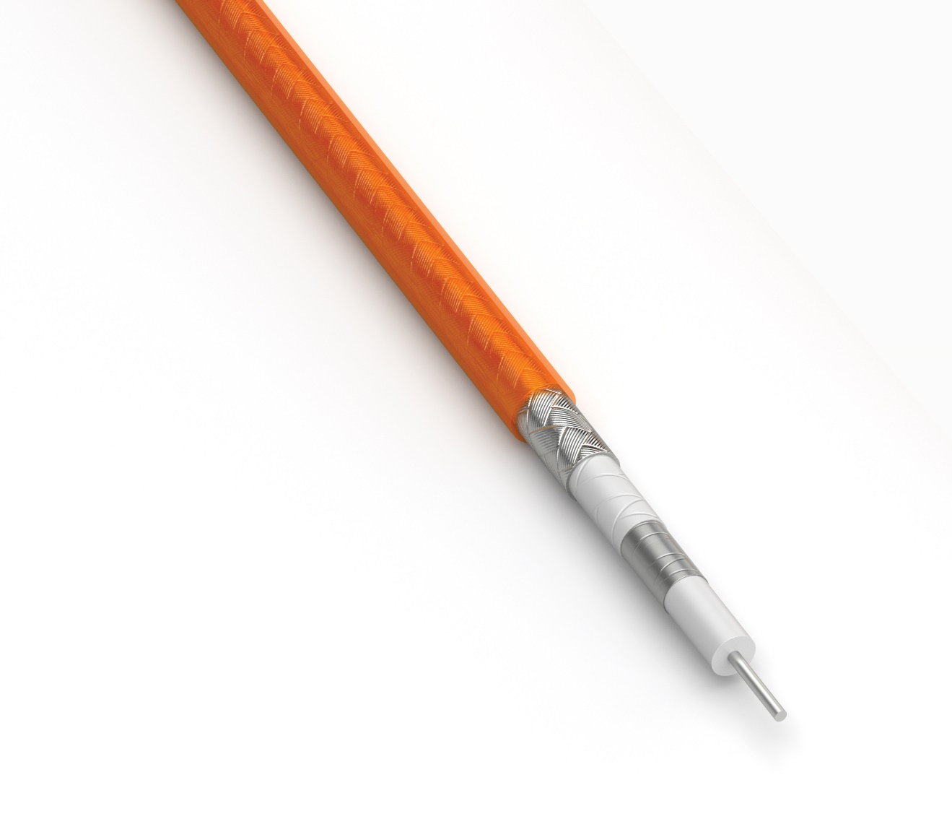
The new PA cable facility is being staffed with highly skilled cable and RF professionals who bring a wealth of knowledge and experience to the production process. The facility is focused on developing next-generation products by harnessing the latest advancements in material science and signal integrity. Samtec Inc. is confident that this new facility will play a key role in supporting our customer’s needs of delivering high-quality products and Sudden Service®.

“Samtec is pleased to announce this exciting opportunity of expanding our cable and RF connector product offering for mil/aero, consumer, medical, and harsh environments. This new manufacturing plant will provide robust product and technology solutions for our customers. Opening this new facility reinforces Samtec’s continued dedication to stay at the forefront of technological advancements in the interconnect industry.” – Brian Vicich, CTO at Samtec

For more information on Samtec and its products and services, please visit: www.samtec.com
For more information on career opportunities available at this or any Samtec location visit: www.samtec.com/careers

About Samtec, Inc.
Founded in 1976, Samtec is a privately held, $1 Billon dollar global manufacturer of a broad line of electronic interconnect solutions, including High-Speed Board-to-Board, High-Speed Cables, Mid-Board and Panel Optics, Precision RF, Flexible Stacking, and Micro/Rugged components and cables. Samtec Technology Centers are dedicated to developing and advancing technologies, strategies, and products to optimize both the performance and cost of a system from the bare die to an interface 100 meters away, and all interconnect points in between. With 40+ international locations and products sold in more than 125 different countries, Samtec’s global presence enables its unmatched customer service. For more information, please visit: http://www.samtec.com.

