FOR IMMEDIATE RELEASE
October 2023
CONTACT: Mediaroom@samtec.com

Samtec Releases Line of DC to 90GHz Connectors with Alignment Features
New Albany, IN: Samtec has fully released its line of vertical solderless, compression mount connectors that incorporate precision alignment features. Spanning DC to 90 GHz, the new connectors are well suited for use in high-frequency test and measurement applications and are available in full production quantities.

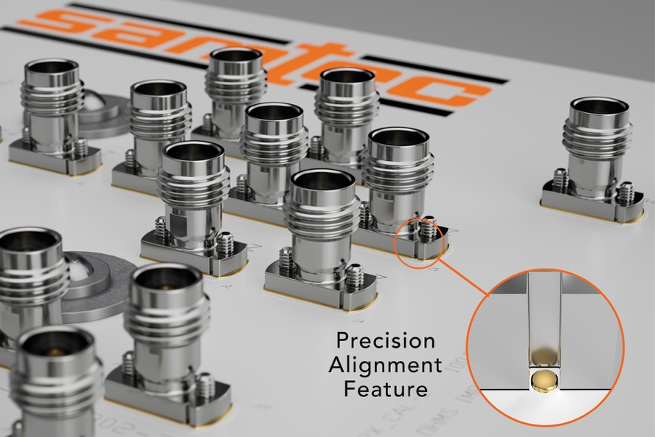
The connectors come standard with precision alignment features that are exclusive to Samtec and ensure peak connector performance. The solderless launch (where the connector is compressed onto the PCB using mounting hardware) allows for easy, field replaceable, cost-effective assembly to the PCB and eliminates possible performance degradation commonly found with solder reflow.

This new line of connectors includes both threaded and push-on interface types:
- 135 Series: 1.35 mm (90 GHz)
- 185 Series: 1.85 mm (65 GHz)
- 240 Series: 2.40 mm (50 GHz)
- 292 Series: 2.92 mm (40 GHz)
- GPPC Series, -CMM option: SMPM (65 GHz)

Complete electrical, mechanical, and environmental specifications are available in the Product Specification Sheets for each series on samtec.com. A brief technical overview, along with board thickness and torque specifications, is available in the eBrochure: samtec.com/solderless-compression.

“In extremely high frequency test and measurement applications, compression mount connectors have become the connector of choice. Samtec has noticed that when compression mounting, slight misalignment between the connector and the landing pad can occur causing signal degradation. While at lower-frequencies this degradation is minor, at high-frequencies it can become problematic yet very difficult to detect. This has been observed even when mounting screws are tightened to proper torque specifications.” says Dan Birch Global RF Engineering Manager at Samtec. “To prevent this issue, alignment features are now standard with all Samtec vertical compression mount RF products.”

GPPC Series for Test & Measurement
For differential pair test and measurement applications, Samtec has released its vertical GPPC Series with a -CMM solderless option. It’s the only ganged, solderless connector of its kind in the industry. The push-on coupling design enables quick-attach for ease of use in a lab setting.

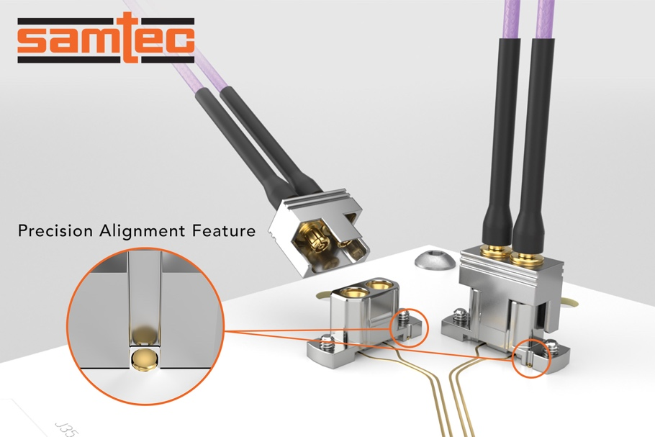

As frequency requirements continue to scale, optimizing the PCB launch structure becomes more important. Engineers looking for assistance with board launch optimization and/or complete channel analysis can contact RFGroup@samtec.com.

Samtec offers a full line of off-the-shelf solutions suitable for microwave and millimeter wave applications from 18 GHz to 110 GHz. Samtec precision RF products support next-generation technology advancements in wireless communication, automotive, radar, SATCOM, aerospace, defense, and test and measurement. Customization of products, both quick-turn modifications and new designs, is also available.

samtec.com/PrecisionRF

-----------------------------

About Samtec, Inc.
Founded in 1976, Samtec is a privately held, $1 Billon dollar global manufacturer of a broad line of electronic interconnect solutions, including High-Speed Board-to-Board, High-Speed Cables, Mid-Board and Panel Optics, Precision RF, Flexible Stacking, and Micro/Rugged components and cables. Samtec Technology Centers are dedicated to developing and advancing technologies, strategies, and products to optimize both the performance and cost of a system from the bare die to an interface 100 meters away, and all interconnect points in between. With 40+ international locations and products sold in more than 125 different countries, Samtec’s global presence enables its unmatched customer service. For more information, please visit: http://www.samtec.com.

Samtec, Inc.

P.O. Box 1147

New Albany, IN 47151-1147

USA

Phone: 1-800-SAMTEC-9 (800-726-8329)

