Samtec FireFlyTM Micro Flyover SystemTM Shipping for Optical and Copper Designs to 28 Gbps

Available in production quantities, the high-performance interconnect systems use the same micro connector in x4, x8, and x12 configurations for copper and optical systems, allowing for increased density, simplified PCB design, and reduced power dissipation.

[New Albany, IN]-- Samtec, Inc., the service leader in the connector industry, is shipping the Optical FireFlyTM Micro Flyover SystemTM, the first interconnect system with the flexibility to use micro-footprint high-performance optical and copper interconnects interchangeably. Consisting of a transceiver, two-piece connector system, and cable, the FireFly Micro Flyover System supports 14, 16, 25, and 28 Gbps designs in x4, x8, and x12 configurations. The products in this announcement are supported by 3D models, a PCI Express®-over-Fiber adaptor card, and evaluation kits available on the Samtec website as part of Samtec Sudden Service®.
Products in the Series
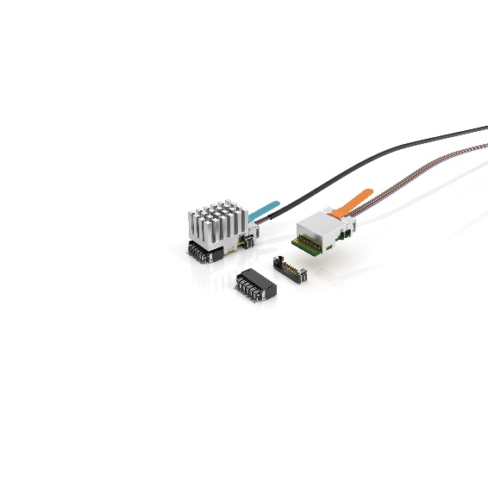
Well suited for use in high-performance designs such as AI/high-performance computing, medical, test & measurement, and FPGA applications, the model ECUO FireFly Active Optical Micro Flyover System cable assembly supports up to 56 Gbps PAM4 SerDes and is designed for near package placement. An extended temperature version (model ETUO) for military, aerospace, and industrial applications, operates across -40°C to +85°C and demonstrates error-free transmission during applied external shock and vibration tests methods specified in MIL-STD-810. (The cost optimized ECUE model comes with copper cable assembly.)
Ideal for high-density applications such as ATE, mil/aero, broadcast video, and factory automation, model PCUO transmits PCIe 3.0/4.0 data rates as well as two sideband signals up to 100 m. The extended temperature version, PTUO, operates across -40°C to +85°C with BER of better than 1E-12. (The cost optimized PCUE series comes with a copper cable assembly.)
Small Size & Ease of Assembly
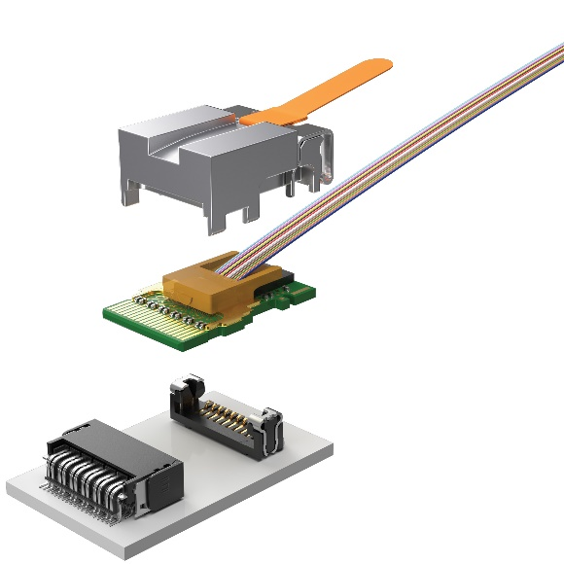
Products in the Optical FireFly Micro Flyover System achieve performance from 14 to 28 Gbps in a miniature footprint covering an area of only 0.63 square inches for an aggregate 265 Gbps/in². All models are interchangeable with FireFly copper or optical cable. The connector system has the industry’s leading miniature footprint, measuring just 11.25 x 21.08 mm, allowing close proximity to the ASIC module.
The rugged two-piece edge card socket system, with weld tabs, latch locking mechanism, and loading guides, provides simplified mating and unmating of the cable assemblies as compared to compression systems, which use mechanical screw downs and hardware. An integral heat sink, available as finned, flat, fiber-groove, or custom designed, further simplifies assembly while improving thermal performance. There are a variety of high-density and rugged end options available.
Excellent Performance
By taking the data connections "off-board" with Samtec Flyover® cables, the signal integrity design is made significantly easier, and the electrical performance improved.
Evaluation Kits and Design Assistance
Samtec currently offers three evaluation kits to support the FireFly Micro Flyover System, the 14 Gbps FireFly FMC Development Kit, 25/28 Gbps FireFly FMC+ Development Kit, and 28 Gbps FireFly Evaluation Kit.
Samtec’s international, multidisciplinary team of technical experts are dedicated to the design, development, manufacturing and application support of bleeding edge optical solutions. For more information and design support, contact FireFly@samtec.com or visit Micro Flyover On-Board Optical Engine, FireFly™ | Samtec
About Samtec
Founded in 1976, Samtec is a privately held global manufacturer of a broad line of electronic interconnect solutions, including High-Speed Board-to-Board, High-Speed Cables, Mid-Board and Panel Optics, Precision RF, Flexible Stacking, and Micro/Rugged components and cables. Samtec Technology Centers develop and advance technologies, strategies, and products to optimize both the performance and cost of a system from the bare die to an interface 100 meters away, and all interconnect points in between. Visit www.samtec.com for more information.

