FOR IMMEDIATE RELEASE
February 2024
CONTACT: Mediaroom@samtec.com

Samtec Introduces 0.635 mm pitch, Slim Body Edge Rate® Connectors

New Albany, IN: Samtec has expanded its successful line of Edge Rate® board-to-board connectors to include a higher density mated set that is half the width of previous designs and offers a lower-profile 5 mm mated height (ERF6 & ERM6 Series). ERF6 & ERM6 Series Edge Rate® connectors support 56 Gbps PAM4 high-speed, rugged mezzanine applications for industrial, embedded vision, instrumentation and monitoring, drones, and robotics.

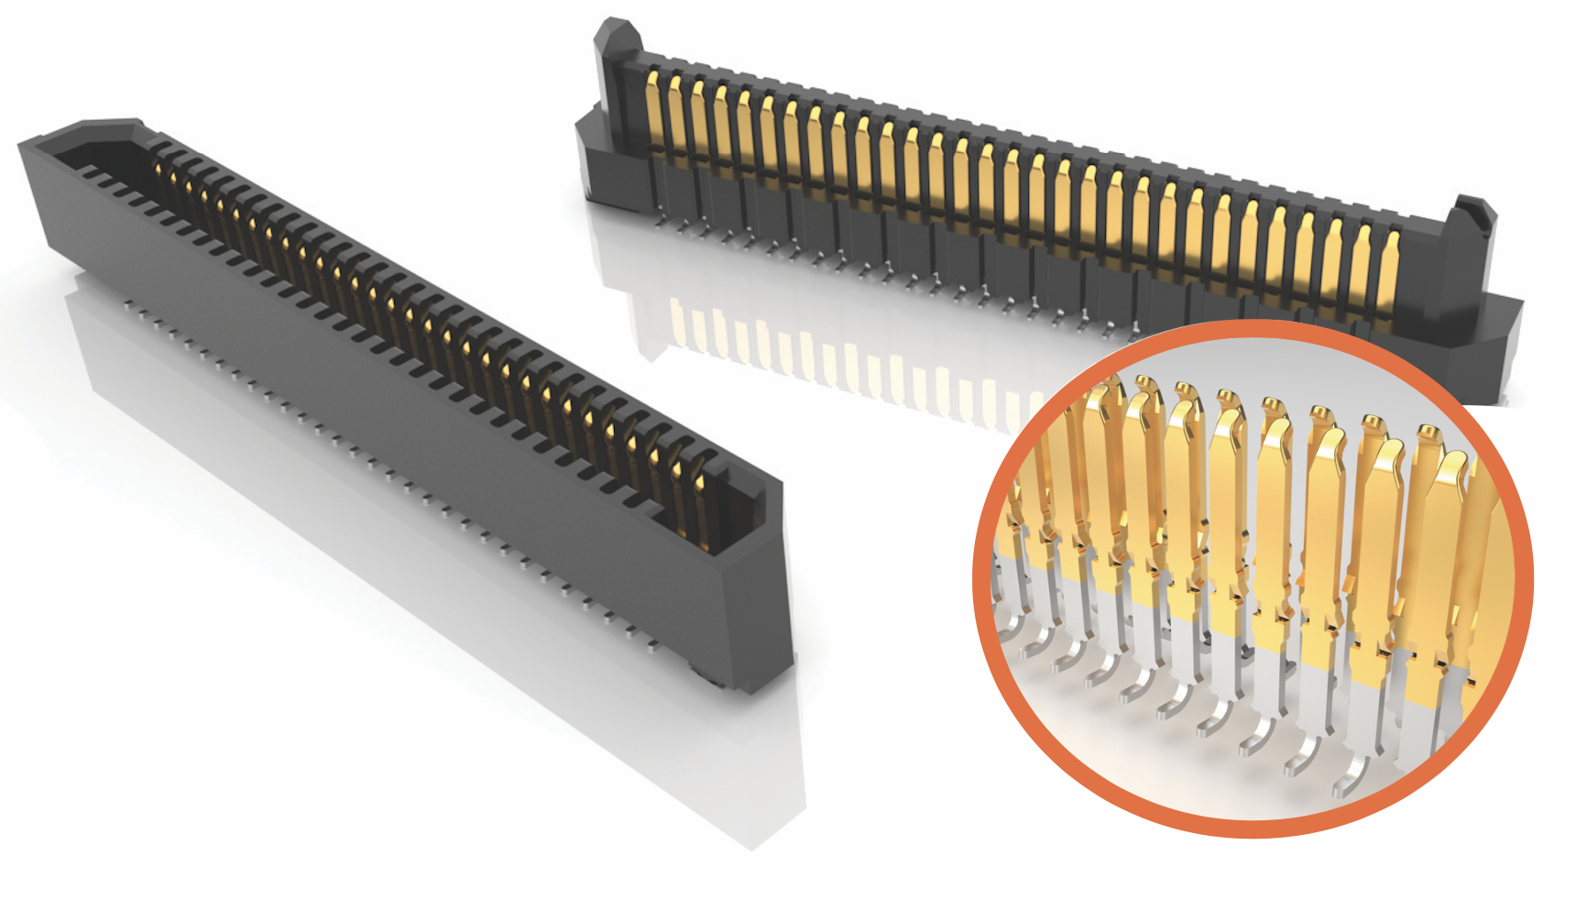

Small & Rugged
ERF6 & ERM6 have two rows of pins while maintaining an extremely narrow body width of 2.5 mm. Body length is 11 mm to 42.8 mm with a 0.635 mm centerline. Available positions for each row are 10, 20, 30, 40, 50 or 60. This makes customization of products easy while still allowing for quick delivery.

If pull and shear force are a concern, weld tabs are available within the standard part number configuration.

Despite its very low profile of 5 mm, the connectors still allow 0.90 mm of nominal contact wipe for a reliable connection.

To ensure connectors are consistently aligned properly, polarizing features are molded into the connector body. As represented in the Product Spec Sheet, ERF6 & ERM6 products allow for angular and linear misalignment.

To further secure the two mating mezzanine cards, board stacking standoffs are available through Samtec (search for Samtec’s SureWare™ brand).

Contact System
Samtec’s Edge Rate® family of products use a unique contact system that extends cycle life, increases durability, and lowers insertion and withdrawal forces. It also has superior electrical performance compared to traditional stamped contacts. These benefits are achieved by using the flat smooth-milled side of the contact for the mating surface, instead of the cut-edge which can have rough microscopic edges and burrs. The narrow edge of the contacts are aligned within the connector body to reduce broadside coupling and crosstalk. The contact tail uses standard surface mount J leads for ease of processing onto the printed circuit board.

Free Product Samples & Model Downloads
Samtec makes designing-in the right product solution as streamlined and easy as possible by offering free 3D model downloads and free product samples. 3D models are available for download at samtec.com in more than 150 formats, including AutoCad, Solid Edge, and Inventor.

Request a free sample or configure and download your 3D model directly from the Series page on the Samtec website: ERF6, ERM6.

To view Samtec’s complete line of Edge Rate® high-speed, rugged connector strips (0.50 mm, 0.635 mm & 0.80 mm centerlines) visit samtec.com/edgerate.

Product Availability
Samtec’s ERF6 & ERM6 Series products are available direct or through distribution.

-----------------------------

About Samtec, Inc.
Founded in 1976, Samtec is a privately held, $1 Billon dollar global manufacturer of a broad line of electronic interconnect solutions, including High-Speed Board-to-Board, High-Speed Cables, Mid-Board and Panel Optics, Precision RF, Flexible Stacking, and Micro/Rugged components and cables. Samtec Technology Centers are dedicated to developing and advancing technologies, strategies, and products to optimize both the performance and cost of a system from the bare die to an interface 100 meters away, and all interconnect points in between. With 40+ international locations and products sold in more than 125 different countries, Samtec’s global presence enables its unmatched customer service. For more information, please visit: http://www.samtec.com.

Samtec, Inc.

P.O. Box 1147

New Albany, IN 47151-1147

USA

Phone: 1-800-SAMTEC-9 (800-726-8329)

