Samtec to Exhibit at OFC 2024, Participate in Interoperability Demo
Samtec products will be showcased in booth #4625 as well as the OIF booth #1323 as part of the OIF Interop demo.
[New Albany, IN]-- Samtec, Inc., the service leader in the connector industry, will be demonstrating next-gen, high-performance optical and copper interconnect solutions at the upcoming OFC 2024 Exhibition, the premier global event for optical communications and networking.
Held in San Diego Convention Center, San Diego, CA March 26-28 2024, OFC will also host the OIF Interoperability Demo. Samtec is one of 47 member company participants in the OIF booth, which will spotlight groundbreaking interoperable solutions in 800ZR, 400ZR and OpenZR+ optics; Energy Efficient Interfaces (EEI) & Co-Packaging; 112G and 224G Common Electrical I/O (CEI); and Common Management Interface Specification (CMIS) implementations.
Samtec Networking Solutions
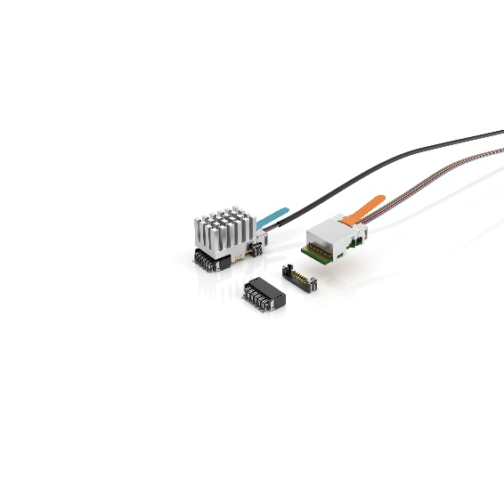
Well suited for use in high-performance designs such as AI/high-performance computing, medical, test & measurement, and FPGA applications, Samtec high-speed interconnects support signals up to 224 Gbps PAM4. This year at OFC, Samtec will have showcase demonstrations in booth #4625 that incorporate the new Si-Fly™ HD for 224 Gbps PAM4, Samtec HaloTM next-generation transceiver for optical and copper, CXL-over-optics featuring the Samtec FireFlyTM, and other Samtec high-performance PAM4 and PCIe 6.0 solutions.
OIF Interoperability Demo
OIF will host a record-setting 47 member companies to showcase interoperable solutions that are addressing the demand for next-generation data center networking, artificial intelligence/machine learning (AI/ML) and disaggregation applications in its booth #1323 at OFC 2024.
Samtec’s products will be included in the CEI demonstrations, specifically the 224G long-range demo, 224G very-short-range demo, and 112G linear demo.
- CEI-224G LR Demo: Samtec Si-Fly™ HD is the industry’s highest-density on-package or ASIC-adjacent cable system. Supporting 207 DPs/in2, Si-Fly HD features Samtec Flyover® Cable Technology and Eye Speed® AIR™ hyper low skew 33 AWG twinax cable.
- CEI-224G VSR Demo: Samtec’s Block Chain ISI Evaluation Board offers 12 variable length signal paths with known loss profiles beyond 70 GHz. When combined with Samtec’s Bulls Eye® High-Performance Test Systems, the combined solution offers an easy-to-use test platform for evaluating and demonstrating 224 Gbps PAM4 signal performance.

- CEI-112G Linear Demo: Samtec’s Linear Direct Drive Evaluation Board offers a proof-of-concept for EO and OE conversions. Speeds of 112 Gbps PAM4 without the use of DSP or other co-packaged solutions are possible. It uses the latest 4×112 Gbps PAM4 laser drivers and VCSELs on the transmit path. Photo diodes and TIAs are used on the receive path.
More Information
For the latest information about Samtec’s OFC 2024 participation, visit OFC 2024 - The Samtec Blog.
For more information on Samtec’s products for 224 Gbps PAM4, visit www.Samtec.com/224.
For more information on Samtec’s Optical products, visit www.samtec.com/optics

About OIF
OIF is where the optical networking industry’s interoperability work gets done. With more than 25 years of effecting forward change in the industry, OIF represents the dynamic ecosystem of 150+ industry leading network operators, system vendors, component vendors and test equipment vendors collaborating to develop interoperable electrical, optical and control solutions that directly impact the industry’s ecosystem and facilitate global connectivity in the open network world. Connect with OIF on LinkedIn, on X at @OIForum and at http://www.oiforum.com.

About Samtec
Founded in 1976, Samtec is a privately held global manufacturer of a broad line of electronic interconnect solutions, including High-Speed Board-to-Board, High-Speed Cables, Mid-Board and Panel Optics, Precision RF, Flexible Stacking, and Micro/Rugged components and cables. Samtec Technology Centers develop and advance technologies, strategies, and products to optimize both the performance and cost of a system from the bare die to an interface 100 meters away, and all interconnect points in between. Visit www.samtec.com for more information.

