FOR IMMEDIATE RELEASE
April 2024
CONTACT: Mediaroom@samtec.com

Samtec Releases Narrow Body RF Edge Launch Connectors from DC to 67 GHz

New Albany, IN: Samtec has released a new line of RF edge launch connectors with a narrow body design that is 33% smaller than traditional edge launch connectors. These connectors are commonly used in a lab setting for high-frequency test and measurement applications, high-speed digital component test and evaluation boards. Frequency capabilities are DC to 67 GHz (185-EL Series), DC to 50 GHz (240-EL Series) and DC to 40 GHz (292-EL Series). Interface types include 1.85 mm, 2.40 mm and 2.92 mm.

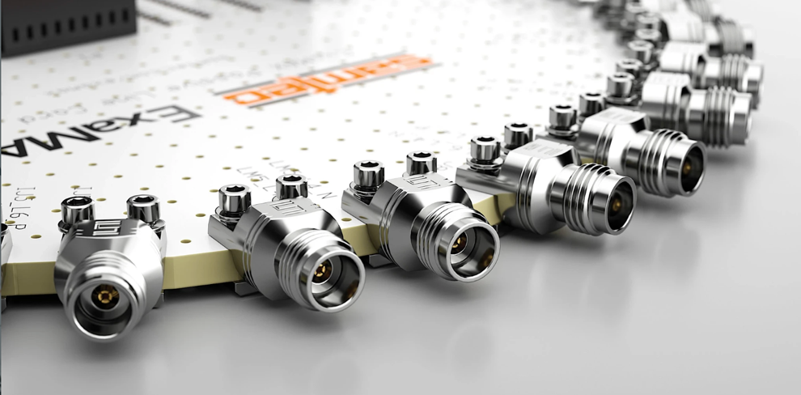

As the name suggests, Samtec’s RF edge launch connectors are installed on the edge of the board. Doing so makes it easy to align the launch pin with the circuit trace, which also helps to ensure proper ground alignment for preventing RF leakage. Samtec’s RF edge launch connectors compression mount to the printed circuit board instead of requiring solder. Proper alignment and the removal of solder allows for increased signal integrity performance capabilities (versus soldered edge launch, or even vertical or angled launch connectors).

The solderless design of the 185-EL, 240-EL and 292-EL Series connectors means they are reusable, also known as field replaceable; with up to 500 mating cycles, this makes them extremely cost-effective. Samtec’s RF edge launch connectors are easy to install and do not cause damage to a printed circuit board.

“When electrical performance is critical, edge launch connectors are often selected in lieu of vertical or angled launch connectors. Samtec worked to enhance the overall connector design for advanced impedance and VSWR performance over other edge launch connectors commonly found in the industry. Combined with Samtec’s Sudden Service® offerings, which include signal integrity and launch optimization services, we anticipate Samtec RF edge launch connectors to quickly find homes in the marketplace.” says David Beraun, RF Product Marketing & Development Manager at Samtec

Engineers looking for assistance with board launch optimization and/or complete channel analysis can contact RFGroup@samtec.com.

Recommended board thickness for Samtec’s solderless RF edge launch connectors is 0.040” to 0.100”. Recommended board mount torque is 0.5 ~ 0.8 in-lbs.

Complete electrical and mechanical data may be located from the Product Spec Sheet on each Series page: 185-EL, 240-EL, 292-EL

Availability: Samtec’s RF edge launch products are in stock and available now, directly from Samtec or through authorized distributors.

Samtec offers a full line of off-the-shelf solutions suitable for microwave and millimeter wave applications from 18 GHz to 110 GHz. Samtec precision RF products support next generation technology advancements in wireless communication, automotive, radar, SATCOM, aerospace, defense, and test and measurement. Customization of products, both quick-turn modifications and new designs, is also available.

-----------------------------

About Samtec, Inc.
Founded in 1976, Samtec is a privately held, $1 Billon dollar global manufacturer of a broad line of electronic interconnect solutions, including High-Speed Board-to-Board, High-Speed Cables, Mid-Board and Panel Optics, Precision RF, Flexible Stacking, and Micro/Rugged components and cables. Samtec Technology Centers are dedicated to developing and advancing technologies, strategies, and products to optimize both the performance and cost of a system from the bare die to an interface 100 meters away, and all interconnect points in between. With 40+ international locations and products sold in more than 125 different countries, Samtec’s global presence enables its unmatched customer service. For more information, please visit: http://www.samtec.com.

Samtec, Inc.

P.O. Box 1147

New Albany, IN 47151-1147

USA

Phone: 1-800-SAMTEC-9 (800-726-8329)

