Samtec Introduces SIBORG Tool to Speed Component Launch Designs
Available freely to Samtec customers under NDA, SIBORG (Signal Integrity Breakout Region Guru) works with Ansys HFSS 3D Layout to generate, visualize, optimize, and develop PCB package and component break out regions (BORs).
[New Albany, IN]-- Samtec, Inc., the service leader in the connector industry, has expanded its Sudden Service® offerings with SIBORGTM, a free tool designed to allow Samtec customers the opportunity to optimize their component launches. Initially intended to be used during design collaboration with experts in Samtec’s Signal Integrity Group (SIG), the tool can also be used independently to rapidly analyze different design variations in the connector breakout region (BOR) that affect signal integrity.
“It is imperative to understand electromagnetics and theory when optimizing vias and launches for high-speed PCB design,” says Scott McMorrow, Chief Technologist for Samtec and the developer of SIBORG. “An automated tool, such as SIBORG, allows designers to make small changes to layer counts, geometry, and transmission line characteristics, and see how that impacts performance without engaging in extensive calculations. And, by standardizing the variables used, SIBORG allows for more efficient collaboration between design teams.”
Variables that can be adjusted in the SIBORG tool include: dielectric variables, such as Dk; PCB manufacturing variables, such as the backdrill drill size; BGA pad geometry variables, such as center-to-center pitch between signal balls; via geometry variables, such as ground via pad diameter; antipad sizing variables, such as antipad in plane below trace layer; trace geometry variables, such as trace width; launch geometry variables, such as center-to-center pitch between signal vias; and BOR array generation variables, such as breakout direction vector. The Samtec SIBORG tool for Ansys HFSS currently supports 70+ variables in nine categories.
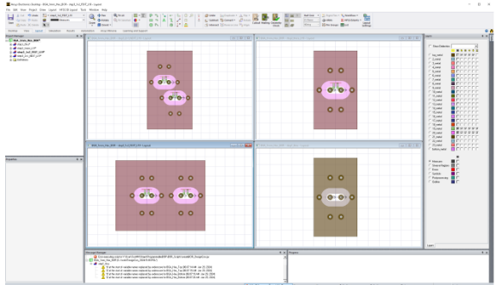
The SIBORG tool has easy-to-use drop-down menus to specify design parameters and generates images to allow engineers to quickly set up, visualize, and analyze the effects of changing the variables. The figure shows a screen shot from rendering a via-in-pad design. SIBORG tool can use all the capabilities of Ansys HFSS 3D Layout, including optimization and plot generation.
After the design is optimized in SIBORG, the results and s-parameters can be transferred to other tools for end-to-end channel simulation. Or, the designer can export the final design into a comprehensive module of PCB BORs and package/connector 3D models.
Introduced during a tutorial session at DesignCon 2024, SIBORG, Signal Integrity Break Out Region Guru, modeling tool for Ansys HFSS can be requested through the Samtec website (www.samtec.com/hfss). More information on SIBORG can be found in the tutorial slides. Samtec SI experts can be reached directly for design assistance at sig@samtec.com.
About Samtec
Founded in 1976, Samtec is a privately held global manufacturer of a broad line of electronic interconnect solutions, including High-Speed Board-to-Board, High-Speed Cables, Mid-Board and Panel Optics, Precision RF, Flexible Stacking, and Micro/Rugged components and cables. Samtec Technology Centers develop and advance technologies, strategies, and products to optimize both the performance and cost of a system from the bare die to an interface 100 meters away, and all interconnect points in between. Visit www.samtec.com for more information.

