**FOR IMMEDIATE RELEASE**

**June 2024**

**CONTACT:** [Mediaroom@samtec.com](mailto:Mediaroom@samtec.com)

**Samtec Expands Popular Magnum RF® Line with Low-Profile Option**

**New Albany, IN:** Samtec’s popular ganged, multi-port SMPM [Magnum RF® product family](https://www.samtec.com/rf/original/magnum/) is now available with an extremely low-profile 3.94 mm (.155") body height, right-angle option for maximum channel density in low- or mid-band systems. Samtec’s GPPC Series offers the industry’s first low-profile, right-angle multi-port solution with performance out to 50 GHz.

Magnum RF® products are ideal when space is limited and a high operating frequency is required. With industry leading density, Magnum RF® also achieves 40-percent greater density and better positional alignment per channel compared to traditional, discrete SMPM interconnects. Applications include phased array radar, 5G/6G networking, military, defense and test & measurement.

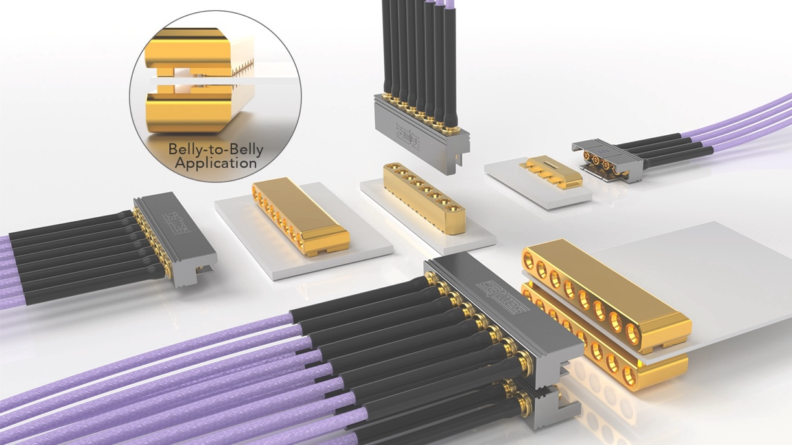

**Maximum Channel Density**

The new low-profile, right-angle option is an evolution of the [GPPC](https://www.samtec.com/products/gppc) Series interconnect, and is the latest release in Samtec’s Magnum RF® product line. Be sure to specify -RA-SM within the GPPC Series part number scheme ([GPPC](https://www.samtec.com/products/gppc), -RA-SM). The 3.94 mm (.155") body height accommodates highly dense systems while the push-on interface aids in mating/unmating.

One way to take full advantage of this new low-profile GPPC -RA-SM design is to assemble it into a belly-to-belly application, with top and bottom placement close to the edge of the board. Belly-to-belly maximizes board real estate while doubling the density and throughput. GPPC -RA-SM will operate mode-free up to 50 GHz per channel with 2, 4, 6, 8 or 10 channels available. Low-profile, mid-board connections are also practical applications.

**Multi-Port SMPM Interface**

When integrating with cable assemblies, the micro-miniature SMPM design lends itself to smaller diameter materials and smaller bundle sizes for weight savings and increased system airflow for cooling. Ganged, Magnum RF® cable assemblies with .047" or .086" size cables are available with a minimum static bend radius of 0.125" or 0.350" ([GC47](https://www.samtec.com/products/gc47) or [GC86](https://www.samtec.com/products/gc86) Series).

When connecting two PCBs, the SMPM interface not only allows for quick, easy mating but also:

* addresses blind-mating when space constraints are a concern.
* compensates for misalignment when paired with a bullet adaptor ([PRFIA](https://www.samtec.com/products/prfia) Series).
* eliminates axial gap when paired with a spring-loaded adaptor, improving return loss.
* enables high mating cycles (100 full detent; 500 smooth bore).
* accommodates varying retention force requirements.

Catalog-standard [Magnum RF® products](https://www.samtec.com/rf/original/magnum/) are single-row with a 3.56 mm (.140") channel pitch. Known for its SMPM-style interface, this broad family of products operates from DC to 65 GHz. Custom channel pitch, custom channel counts and multi-row designs are available. Contact [RFgroup@samtec.com](mailto:RFgroup@samtec.com).

Samtec offers a full line of off-the-shelf solutions suitable for microwave and millimeter wave applications from 18 GHz to 110 GHz. Samtec precision RF products support next generation technology advancements in wireless communication, automotive, radar, SATCOM, aerospace, defense, and test and measurement. Customization of products, both quick-turn modifications and new designs, is also available.

[Download](https://suddendocs.samtec.com/literature/samtec_precision_rf_design_guide.pdf?_gl=1*su4uqy*_ga*NjE3NDU2Nzk0LjE3MTYzMTMyNjk.*_ga_3KFNZC07WW*MTcxNjMyMTU3My4zLjEuMTcxNjMyMTY4Mi42MC4wLjA.) Samtec’s new [Precision RF Design Guide](https://suddendocs.samtec.com/literature/samtec_precision_rf_design_guide.pdf?_gl=1*su4uqy*_ga*NjE3NDU2Nzk0LjE3MTYzMTMyNjk.*_ga_3KFNZC07WW*MTcxNjMyMTU3My4zLjEuMTcxNjMyMTY4Mi42MC4wLjA.) for an overview of our latest products and technologies.

-----------------------------

**About Samtec, Inc.**

Founded in 1976, Samtec is a privately held, $1 Billion global manufacturer of a broad line of electronic interconnect solutions, including High-Speed Board-to-Board, High-Speed Cables, Mid-Board and Panel Optics, Precision RF, Flexible Stacking, and Micro/Rugged components and cables. Samtec Technology Centers are dedicated to developing and advancing technologies, strategies, and products to optimize both the performance and cost of a system from the bare die to an interface 100 meters away, and all interconnect points in between. With 40+ international locations and products sold in more than 125 different countries, Samtec’s global presence enables its unmatched customer service. For more information, please visit: <http://www.samtec.com>.

**Samtec, Inc.**

**P.O. Box 1147**

**New Albany, IN 47151-1147**

**USA**

**Phone: 1-800-SAMTEC-9 (800-726-8329)**