Samtec to Showcase High-Performance Interconnects at electronica 2024
Samtec will take customer meetings and demonstrate high-density optical, copper, and RF interconnects in booths B2-219 and B2-119.
October xx, 2024 [New Albany, IN]-- Samtec, Inc., the service leader in the connector industry, will be demonstrating next-generation, high-performance optical and copper interconnect solutions at electronica 2024, the world’s leading trade fair that provides a comprehensive product and technology update for all fields of electronics. Occurring every two years, electronica (12-15 November) attracts approximately 70,000 attendees to Munich, Germany from over 100 countries. Samtec regularly exhibits at electronica and this year will have live booth demonstrations of industry-leading interconnect products and technology.
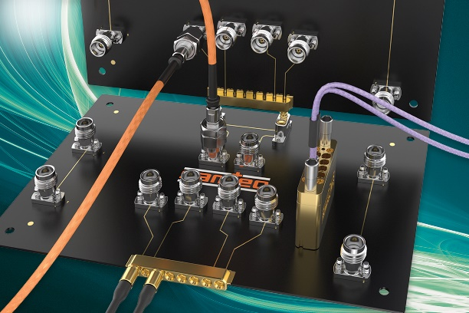
In booths B2-219 and B2-119, Samtec will be showcasing high-speed, high-density interconnects that are well suited for use in datacenters, AI/high-performance computing, instrumentation, aerospace/defense, and telecom/edge applications up to 224 Gbps and 110 GHz.
Products featured include the new Si-FLY® HD, URSA® I/O ultra rugged cable system, AcceleRate® extreme density and performance systems, and HaloTM next-gen 56 Gbps optical system for optical or copper interconnects, CXL over optics, and PCIe. Demonstrations include high-performance mid-board, front-panel, and back-panel systems as well as precision RF products, including the sought-after BE90A Bulls Eye® test system, Magnum RF® ganged solution, and newly released distinctive orange NitrowaveTM RF microwave cable assemblies that maintain phase and amplitude stability with flexure.
About Samtec
Founded in 1976, Samtec is a privately held, $1 Billion dollar global manufacturer of a broad line of electronic interconnect solutions, including High-Speed Board-to-Board, High-Speed Cables, Mid-Board and Panel Optics, Precision RF, Flexible Stacking, and Micro/Rugged components and cables. Samtec Technology Centers are dedicated to developing and advancing technologies, strategies, and products to optimize both the performance and cost of a system from the bare die to an interface 100 meters away, and all interconnect points in between. With 40+ international locations and products sold in more than 125 different countries, Samtec’s global presence enables its unmatched customer service. For more information, please visit: www.samtec.com.
Our press team enjoys working with journalists around the world to share compelling and innovative stories. If you are a member of the media/press and would like to talk, please send an email to mediaroom@samtec.com.

