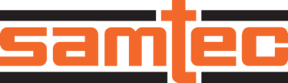

FOR IMMEDIATE RELEASE
November 2024
CONTACT: Mediaroom@samtec.com

Samtec Releases Nitrowave™ High-Performance
LL043 Series Microwave Cable Assemblies to 43.5 GHz

Phase and Amplitude Stable Flexible Cable Assemblies

New Albany, IN: Samtec, Inc., a leader in high-speed connectivity, is announcing full production quantity availability of its LL043 Series Nitrowave™ high-performance microwave cable assembly. Nitrowave™ is Samtec’s new flexible, low-loss microwave coaxial cable product line that demonstrates outstanding amplitude and phase stability in test and measurement, as well as 5G datacom, defense, aerospace and computer/semiconductor applications. Nitrowave™ is easily recognizable by its distinctive orange color and is backed by Samtec Sudden Service® which includes part availability, quick delivery, and access to people and tools that help streamline a design process.

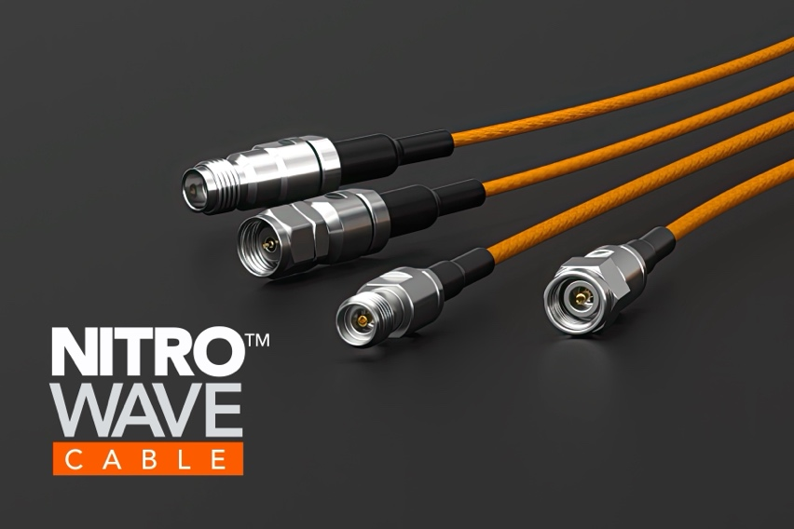

Phase and amplitude stability with flexure is possible due to the optimized construction of Samtec’s orange Nitrowave™ cable. The inclusion of an interlayer enables consistent electrical performance throughout the cable’s life span while the low-density PTFE dielectric material ensures mechanical robustness. Flex life was tested to 400,000 cycles (with unrestrained flexing) and torque life to 1,000,000 cycles (+/- 90-degrees).

Samtec’s LL043 Series performance is optimized to 43.5 GHz; with a maximum VSWR of 1.4:1. During product development, frequency capability was purposefully designed to go beyond traditional industry targets in support of advancing applications and spectrum allocation allowing for 30-percent better insertion loss performance at next generation frequencies. State-of-the-art shielding techniques, with consistent contact resistance between layers, results in 100 dB minimum shielding effectiveness against electromagnetic interference (per IEC 61000-4-21 specifications).

Connector end options include SMA plug or SMA bulkhead jack (to 26.5 GHz), or 2.92 mm and 2.4 mm plugs (to 43.5 GHz). LL043 is available in standard assembly lengths of 305 mm (12-inch), 610 mm (24-inch) and 1000 mm (39.37-inch). Additional mechanical and environmental data is available from the LL043 Series Product Spec Sheet found at samtec.com?LL043. For more information on Samtec’s LL043 Series, Nitrowave™ high-performance microwave cable assemblies, contact RFgroup@samtec.com.

-----------------------------

About Samtec, Inc.
Founded in 1976, Samtec is a privately held, $1 Billion global manufacturer of a broad line of electronic interconnect solutions, including High-Speed Board-to-Board, High-Speed Cables, Mid-Board and Panel Optics, Precision RF, Flexible Stacking, and Micro/Rugged components and cables. Samtec Technology Centers are dedicated to developing and advancing technologies, strategies, and products to optimize both the performance and cost of a system from the bare die to an interface 100 meters away, and all interconnect points in between. With 40+ international locations and products sold in more than 125 different countries, Samtec’s global presence enables its unmatched customer service. For more information, please visit: http://www.samtec.com.

Samtec, Inc.

P.O. Box 1147

New Albany, IN 47151-1147

USA

Phone: 1-800-SAMTEC-9 (800-726-8329)

