Samtec Showcases 200+ Gbps Active Channels at OFC 2025
Samtec high-density copper and optical interconnect products are being demonstrated in Booth #5863.
March 25, 2025 [New Albany, IN]-- Samtec, Inc., the service leader in the connector industry, is demonstrating next-generation, high-performance copper and optical interconnect solutions at OFC 2025 Exhibition (San Francisco, CA; April 1-3, 2025). Samtec will showcase active demonstrations of cables and connectors supporting data rates up to 224 Gbps PAM4 and signals up to 110 GHz.
Introducing Co-Packaged Connectivity for 200+G
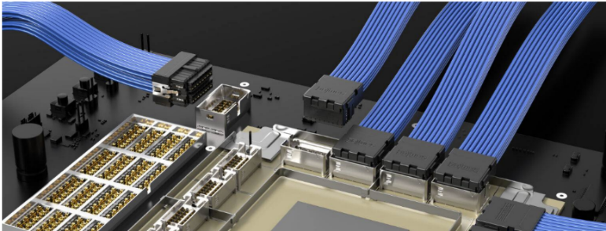
In Booth #5863, Samtec will unveil an active channel demonstration with its technical partner Broadcom, introducing the capabilities of the new Si-Fly® HD co-packaged cable assemblies to Samtec Flyover® OSFP over the new Samtec Eye Speed® Hyper Low Skew twinax cable. This evaluation platform incorporates Broadcom’s industry-leading 200G SerDes technology and Samtec’s co-packaged Flyover technology. Si-Fly HD CPC offers the industry’s highest footprint density and robust interconnect which enables 102.4T (512 lanes at 200G) in a 95 x 95 mm chip substrate.
Co-packaged copper connectivity eliminates insertion losses in the BGA breakout and the PCB. This technology makes a complete 224G passive DAC channel possible, enabling a low-power, cost-effective linear pluggable optics front panel solution with immense potential for connectivity in emerging AI architectures.
Leading-Edge Interconnect Demonstrations
Samtec will also be showing Si-Fly HD near-chip configurations operating at 224 Gbps; Samtec's Bulls Eye® 90GHz ISI Evaluation Board; Samtec’s OCP OAI EXP Module equipped with sixteen 25Gx4 FireFlyTM optical transceivers; and a 112 Gbps PAM4 demonstration incorporating Samtec's new HaloTM optical and copper systems.
OIF Interoperability Demo
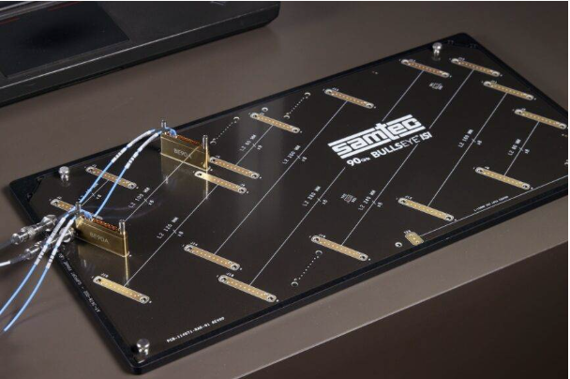
Samtec will be participating in the OIF Interoperability demo at OFC 2025 in booth #5745. This demonstration will highlight advancements in interoperability tailored to address the growing demands of future-oriented data centers, AI/ML technologies, and disaggregated systems.
Samtec’s products will be included in CEI interoperability demonstrations, specifically the 224G long-range demo, 224G very-short-range demo, and 112G linear demo.
- Samtec’s Bulls Eye® ISI Evaluation Board offers numerous variable length signal paths with known loss profiles beyond 90 GHz. When combined with Samtec’s Bulls Eye High-Performance Test Systems, the combined solution offers an easy-to-use test platform for evaluating and demonstrating 224 Gbps PAM4/448 Gbps PAMx signal performance.
- Samtec’s Bulls Eye High-Performance Test System features a high-density space saving design that enables smaller evaluation boards and shorter trace lengths in test and measurement applications. The Bulls Eye block compression mounts adjacent to the SerDes being characterized. End 2 of the cable assembly connects to instrumentation using precision RF connectors as small as 1.00 mm.
More Information
OFC 2025 expects to attract 13,000+ registrants from 80+ countries. Major topics include 1.6 Terabit, AI, Coherent PON, Linear Pluggable Optics (LPO), multicore fiber, data center technology, and quantum networking. In support of these and other applications, Samtec engineers will be in OFC booth #5863 to help designers find the optimal interconnect solution. For more product information, see:
- Samtec’s products for 224 Gbps PAM4, visit www.Samtec.com/224
- Samtec’s optics transceiver solutions High Performance Active Optics & Passive Optics Solutions | Samtec

About OIF
OIF Interoperability Demo at OFC 2024 Features Nearly 50 Companies Addressing Unprecedented Demand for Next-Generation Network Solutions
OIF’s interoperability demonstration at OFC 2024 (booth #1323) will feature 47 member companies showcasing breakthrough solutions in speed, power and density in four key areas: 800ZR, 400ZR and OpenZR+ optics, Energy Efficient Interfaces (EEI), Common Electrical I/O (CEI) channels and Common Management Interface Specification (CMIS) implementations. For more information, visit: https://www.oiforum.com/meetings-events/oif-ofc-2024/
About Samtec
Founded in 1976, Samtec is a privately held, $1 Billion global manufacturer of a broad line of electronic interconnect solutions, including High-Speed Board-to-Board, High-Speed Cables, Mid-Board and Panel Optics, Precision RF, Flexible Stacking, and Micro/Rugged components and cables. Samtec Technology Centers are dedicated to developing and advancing technologies, strategies, and products to optimize both the performance and cost of a system from the bare die to an interface 100 meters away, and all interconnect points in between. With 40+ international locations and products sold in more than 125 different countries, Samtec’s global presence enables its unmatched customer service. For more information, please visit: www.samtec.com.
Our press team enjoys working with journalists around the world to share compelling and innovative stories. If you are a member of the media/press and would like to talk, please send an email to mediaroom@samtec.com.

