

FOR IMMEDIATE RELEASE
April 2025
CONTACT: Mediaroom@samtec.com

Samtec Si-Fly® LP, Low-Profile Cable Assemblies
Capable of Residing Under IC Cooling Hardware

Samtec’s Si-Fly® LP cable assemblies target Data Center, HPC and AI applications where z-axis height is limited near the IC package.

New Albany, IN: Samtec, Inc., the service leader in the connector industry, announces production quantity availability of Si-Fly® LP low-profile cable assemblies. The extremely low 4.35 mm mated height of Si-Fly® LP cable-to-board assemblies allow side-to-side, front-to-back or belly-to-belly PCB mounting near the IC package, with secure placement under heat sinks or other cooling hardware where z-axis height is limited.

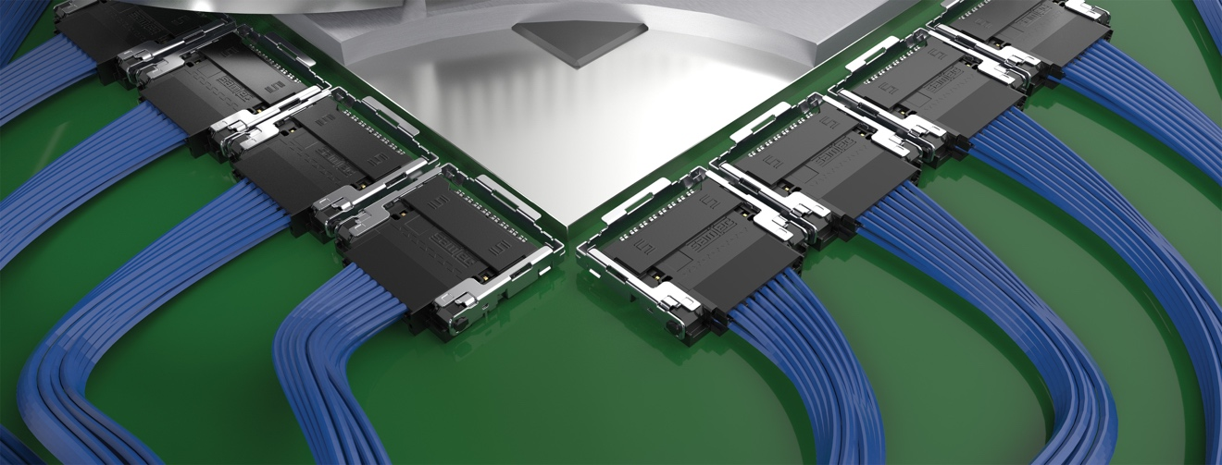

Each Si-Fly® LP cable assembly provides 112 Gbps PAM4 channel rate in a 2-row, 16-pair design with aggregate data rates of 896 Gbps (x8 bi-directional) or 1.79 Tbps (x16 uni-directional) and is PCIe® 6.0/CXL® 3.2 capable. Routing signals from the chip through high-density, high-performance Flyover® cable reduces thermal challenges, simplifies board layout and improves overall cost by eliminating expensive re-timers and allowing for fewer board layers and less expensive printed circuit board materials.

Si-Fly® LP cable assemblies feature Samtec’s proprietary 34 AWG, 92 Ohm ultra-low-skew Eye Speed® twinax cable. Eye Speed® twinax enables superior signal integrity performance using advanced co-extrusion techniques that optimize symmetry between signal conductors and shielding, achieving extremely low intrapair skew. Signal reach and integrity become increasingly important in high-speed Data Center, HPC and AI applications where Si-Fly® LP is commonly deployed. Each design is unique, so Samtec works with system architects early in the process to create solutions for cable management and thermal load distribution.

Samtec’s Si-Fly® LP cable systems (CPC, CPI) are in stock directly from Samtec. For more information on Si-Fly® LP, visit samtec.com/SiFly-LP or contact HDR@samtec.com.

-----------------------------

About Samtec, Inc.
Founded in 1976, Samtec is a privately held, $1 billion global manufacturer of a broad line of electronic interconnect solutions, including High-Speed Board-to-Board, High-Speed Cables, Mid-Board and Panel Optics, Precision RF, Flexible Stacking, and Micro/Rugged components and cables. Samtec Technology Centers are dedicated to developing and advancing technologies, strategies, and products to optimize both the performance and cost of a system from the bare die to an interface 100 meters away, and all interconnect points in between. With 40+ international locations and products sold in more than 125 different countries, Samtec’s global presence enables its unmatched customer service. For more information, please visit: http://www.samtec.com.

Samtec, Inc.

P.O. Box 1147

New Albany, IN 47151-1147

USA

Phone: 1-800-SAMTEC-9 (800-726-8329)

