**Samtec Announces Hyper Low Skew Twinax Cable for 224 Gbps**

*Samtec expands its Eye Speed® cable family with twinax cable specifically developed for 224 Gbps PAM4 systems.*

**April 29, 2025 [New Albany, IN**]-- Samtec, Inc., the service leader in the connector industry, has expanded its Eye Speed® cable family to include Eye Speed Hyper Low Skew Twinax cable optimized for 224 Gbps PAM4 applications. Samtec is currently offering 32 AWG Eye Speed Hyper Low Skew Twinax for inside-the-box cable solutions, with 27 AWG in development for longer reach cabled backplane systems.

**Industry-Leading Skew Performance**

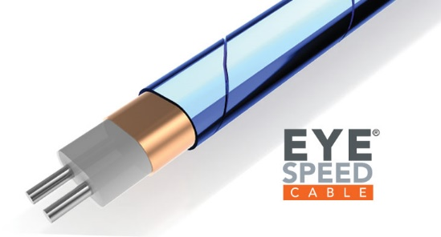Skew is a major design concern for 224 Gbps PAM4, manifesting as delay differences within a differential pair (due to physical and electrical construction in the channel). Samtec has engaged in significant R&D as regards to the impact of skew, resulting in the development of Eye Speed Hyper Low Skew Twinax cable.

Tightly coupled, twinax cable that is co-extruded with drainless shield construction, like the Eye Speed product family, has superior skew performance (as well as impedance and insertion loss stability) even under realistic bending conditions, allowing skew to be completely under the implementer’s control. This is in contrast to other manufacturing techniques for twinax cables that are not co-extruded.

Eye Speed Hyper Low Skew Twinax was specifically developed to target applications where designers need optimal high-speed performance out to 60+ GHz Nyquist frequencies. By holding a maximum intrapair skew of 1.75 ps/m, and offering extreme signal stability, Samtec’s Hyper Low Skew Twinax has the best digital differential pair transmission line performance in the industry.

**Design Flexibility**

Samtec [Eye Speed® Cable Technology](https://www.samtec.com/solutions/eyespeed/) includes 4 varieties: Eye Speed Twinax (3.5 ps/meter max skew; 28-36 AWG); Eye Speed Thinax (40% smaller diameter than Eye Speed Twinax, same performance; 34 AWG); Eye Speed Hyper Low Skew Twinax (1.75 ps/meter max skew; 32 AWG with 27 AWG in development); and Eye Speed ThinSETM (thin micro-coax with 0.024” outer diameter cable).

As part of Samtec’s Sudden Service® initiative, Eye Speed cables take a mix-and-match approach with Samtec’s most popular connectors. In other words, a designer can specify what connector is part of each end of the cable assembly. Some of the more popular mixed-end designs include ExaMAX® to AcceleRate® and FQSFP-D8 to NovaRay® connectors. For 224 Gbps applications, a designer could choose Si-Fly® HD Co-Packaged CPX Substrate Connector over Eye Speed Hyper Low Skew Twinax cable  to a Flyover® OSFP 224 Gbps Panel Assembly, for example.

The mix-and-match strategy allows system architects to specify Samtec high-speed cable solutions for mid-board to mid-board applications, or near-chip/on-chip to front panel, or ASIC-adjacent to the backplane. Whether PCB-attach or Direct-attach type cable assemblies, Samtec’s HDR Group [hdr@samtec.com], consisting of knowledgeable application engineers, can propose and tailor solutions for the exact customer application requirements.

**About Samtec**

Founded in 1976, Samtec is a privately held, $1 Billion global manufacturer of a broad line of electronic interconnect solutions, including High-Speed Board-to-Board, High-Speed Cables, Mid-Board and Panel Optics, Precision RF, Flexible Stacking, and Micro/Rugged components and cables. Samtec Technology Centers are dedicated to developing and advancing technologies, strategies, and products to optimize both the performance and cost of a system from the bare die to an interface 100 meters away, and all interconnect points in between. With 40+ international locations and products sold in more than 125 different countries, Samtec’s global presence enables its unmatched customer service. For more information, please visit: [www.samtec.com](http://www.samtec.com).

Our press team enjoys working with journalists around the world to share compelling and innovative stories. If you are a member of the media/press and would like to talk, please send an email to [mediaroom@samtec.com](mailto:mediaroom@samtec.com).