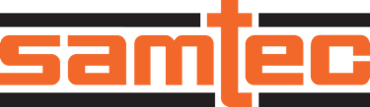

FOR IMMEDIATE RELEASE
June 2025
CONTACT: Mediaroom@samtec.com

Samtec Releases Nitrowave™ Phase and Amplitude
Stable Microwave Cable Assemblies to 110 GHz

Samtec’s Nitrowave high-performance microwave cables provide stability during flexure in lab test environments, ATE systems, and low-loss rugged environments such as aerospace, defense and datacom.

New Albany, IN: Samtec, Inc., the service leader in the connector industry, announces production quantity availability of its highly stable, low-loss flexible microwave cable assemblies using Nitrowave™ cable technology. Nitrowave cable – recognizable by the distinctive Samtec orange FEP jacket – is available in target frequencies of 32 GHz, 43.5 GHz, 71 GHz, 95 GHz and 110 GHz with the following product series: LL032, LL043, LL071, LL095 and LL110. Excellent stability is achieved through Nitrowave cable’s novel construction and investments in high-end manufacturing technologies allowing advancements in process controls.

A Dynamic Performance Layer (DPL) improves durability and stability of the cable by eliminating friction between shielding and augmenting strength. This results in more accurate, dependable performance throughout the service life of the cable, even when subjected to consistent movement and bending. Download the Nitrowave Cable Stability Document for test data by cable type.

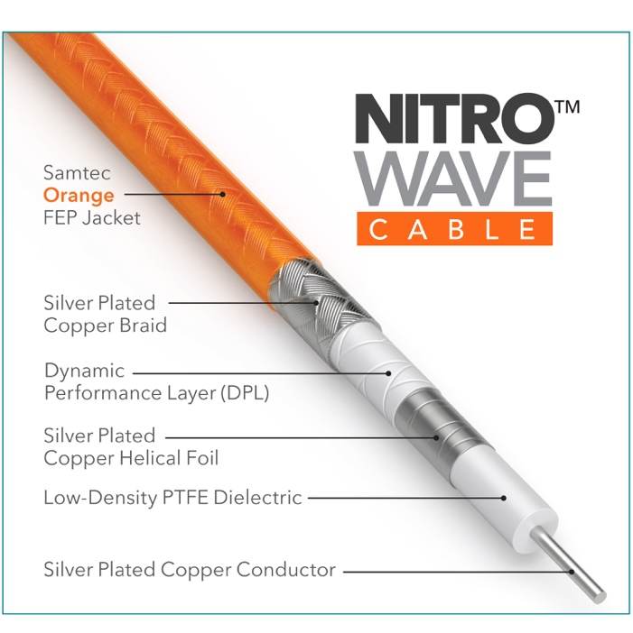

Samtec’s orange Nitrowave cable is available with a variety of connector end options and cable lengths for application-specific adaptability. Connector end options include 1.0 mm, 1.85 mm, 2.40 mm, 2.92 mm, and SMA. Catalog-standard assembly lengths are 305 (12-inch), 610 mm (24-inch) and 1000 mm (39.37-inch); custom cable lengths are also available. Optional phase matching of cable pairs to 1, 2 or 5 pico-seconds allows precise timing and optimal signal integrity of differential pair signaling.

Target applications include lab test environments such as test & measurement and high-speed digital testing, ATE systems, and low-loss rugged environments such as aerospace, defense and datacom. During product development, frequency capability was purposefully designed to go beyond traditional industry targets in support of advancing applications and spectrum allocation, improving insertion loss performance.

Samtec’s Nitrowave cable assemblies are in stock directly from Samtec. For more information visit samtec.com/nitrowave or contact RFgroup@samtec.com.

-----------------------------

About Samtec, Inc.
Founded in 1976, Samtec is a privately held, $1 Billion global manufacturer of a broad line of electronic interconnect solutions, including High-Speed Board-to-Board, High-Speed Cables, Mid-Board and Panel Optics, Precision RF, Flexible Stacking, and Micro/Rugged components and cables. Samtec Technology Centers are dedicated to developing and advancing technologies, strategies, and products to optimize both the performance and cost of a system from the bare die to an interface 100 meters away, and all interconnect points in between. With 40+ international locations and products sold in more than 125 different countries, Samtec’s global presence enables its unmatched customer service. For more information, please visit: http://www.samtec.com.

Samtec, Inc.

P.O. Box 1147

New Albany, IN 47151-1147

USA

Phone: 1-800-SAMTEC-9 (800-726-8329)

