

FOR IMMEDIATE RELEASE
September 2025
CONTACT: Mediaroom@samtec.com

Samtec Launches 800-Position AcceleRate® HP
High-Performance Array Connectors

AcceleRate® HP high-performance array connectors feature 112 Gbps PAM4 performance, a flexible open pin field design, and a highly reliable Solder Column Termination.

New Albany, IN: Samtec, Inc., a global leader in high-performance interconnect solutions and a service leader in the industry, announces the expansion of its AcceleRate® HP product line with the release of 800-position APM6 and APF6 high-performance array connectors available in a low-profile 5mm stack height.
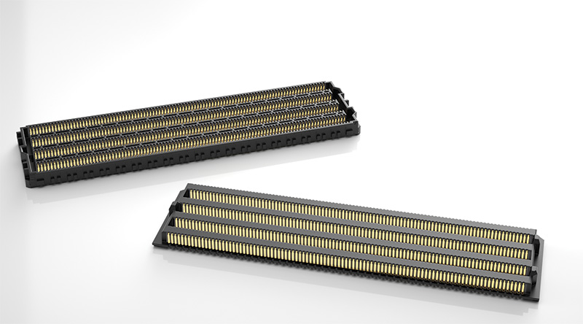
Engineered for next-generation demands, the new AcceleRate® HP connectors deliver exceptional signal integrity and density, supporting data rates up to 112 Gbps PAM4 on a 0.635mm pitch. These connectors are optimized for high-throughput applications such as High-Performance Computing (HPC), Artificial Intelligence (AI), storage, and networking.
Key features include:
- Protocol compatibility with PCIe® 6.0, CXL® 3.2, and 100 GbE
- 800-position configuration (8 rows × 100 positions) in a dense footprint of 68.62mm × 18.20mm (2.701” × 0.717”)
- 5mm mated stack height, with a 10mm version planned for Q2 2026
- 92.5 Ohm impedance
- 1.2 A max current rating (one pin powered per row), and 150 VAC (212 VDC) max voltage rating
- Open pin field array design for maximum grounding and routing flexibility

The APM6 and APF6 connectors utilize Samtec’s Solder Column Termination, enhancing structural integrity. This IPC Class 3 compliant method is ideal for dense, high-speed interconnects and offers superior solder joint reliability and excellent insertion loss and return loss performance.
“These new 800-position connectors represent a significant advancement in high-density, high-speed interconnect technology,” said Eric Mings, Samtec’s High-Speed Board-to-Board Product Manager. “They’re designed to meet the rigorous demands of today’s data-intensive systems while maintaining reliability.”
Samtec’s APM6 and APF6 products are available directly through Samtec or through authorized distribution partners. For more information, visit samtec.com/accelerateHP or contact the High-Speed Board-to-Board Group at HSB2B@samtec.com.
-----------------------------

About Samtec, Inc.
Founded in 1976, Samtec is a privately held, $1 Billion global manufacturer of a broad line of electronic interconnect solutions, including High-Speed Board-to-Board, High-Speed Cables, Mid-Board and Panel Optics, Precision RF, Flexible Stacking, and Micro/Rugged components and cables. Samtec Technology Centers are dedicated to developing and advancing technologies, strategies, and products to optimize both the performance and cost of a system from the bare die to an interface 100 meters away, and all interconnect points in between. With 40+ international locations and products sold in more than 125 different countries, Samtec’s global presence enables its unmatched customer service. For more information, please visit: http://www.samtec.com.

Samtec, Inc.

P.O. Box 1147

New Albany, IN 47151-1147

USA

Phone: 1-800-SAMTEC-9 (800-726-8329)

