FOR IMMEDIATE RELEASE
Samtec Showcases 224 and 448 Gbps High-Performance Interconnect Solutions at DesignCon 2026
New Albany, IN: Samtec, Inc., the service leader in the connector industry, announces it will showcase high-performance interconnect solutions and enabling technologies that support data rates up to 448 Gbps and signals up to 130 GHz in booth #939 at DesignCon 2026 in Santa Clara, CA on February 25-26. Attendees can register with the Samtec VIP code: INVITE373903 to receive a free Expo Pass or 15% discount for conference passes.
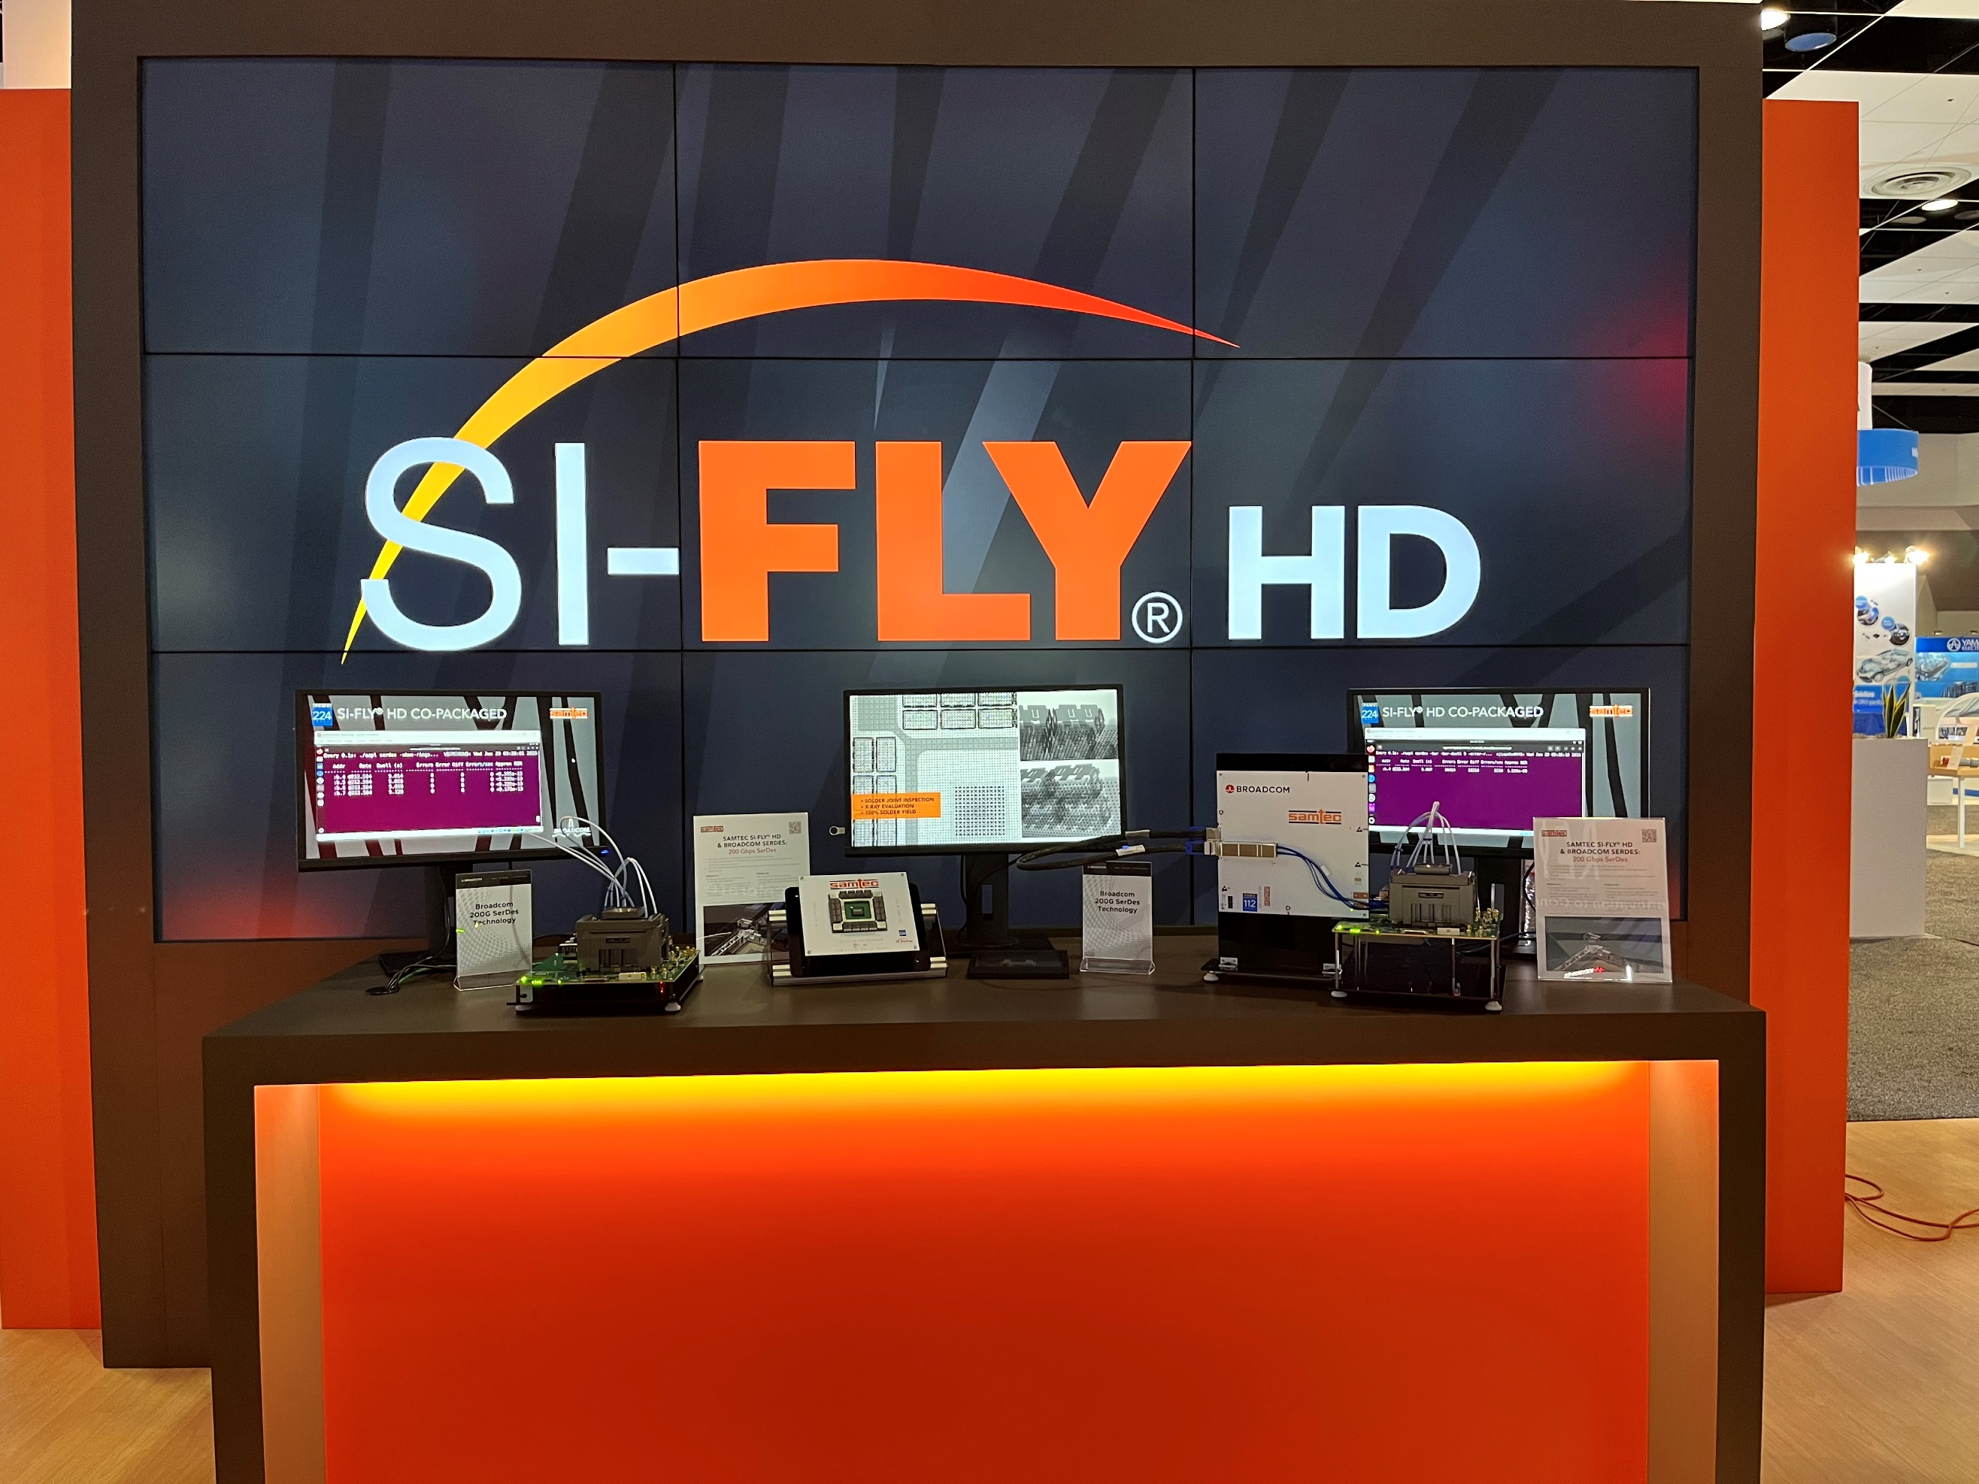
Visit Booth 939 Wednesday and Thursday
Samtec will be celebrating 50 years of Sudden Service® in Booth #939. In-booth engineering experts can help attendees find the optimal interconnect solution, whether it is copper or optics; connectors, cable systems, or discrete wire; RF or digital signals operating at 56 Gbps, 112 Gbps, 224 Gbps, or 448 Gbps.
Samtec’s world-renowned engineering team has been examining the challenges of 224 Gbps and 448 Gbps design and developing new product and enabling technology solutions. The main counter highlights Samtec’s CPX offerings including co-packaged copper (CPC) and co-packaged optics (CPO), including active demonstrations of Si-Fly® HD CPC connectors operating at 224 Gbps.
Other booth demonstrations include the new Si-Fly® backplane system demonstration that supports 224 Gbps signals. A 112 Gbps active optics demonstration incorporates Samtec’s FireFlyTM and new HaloTM products.
Samtec’s distinctive orange NitrowaveTM RF cable is part of the new Bulls Eye BE71A test assembly for 224Gbps PAM4 SERDES as well as the new Bulls Eye BE130 test assembly running 448 Gbps differential signals for test channels. Samtec will also showcase advancements in material science with SureCoat ultra-rugged coatings for high temperatures and harsh environments.
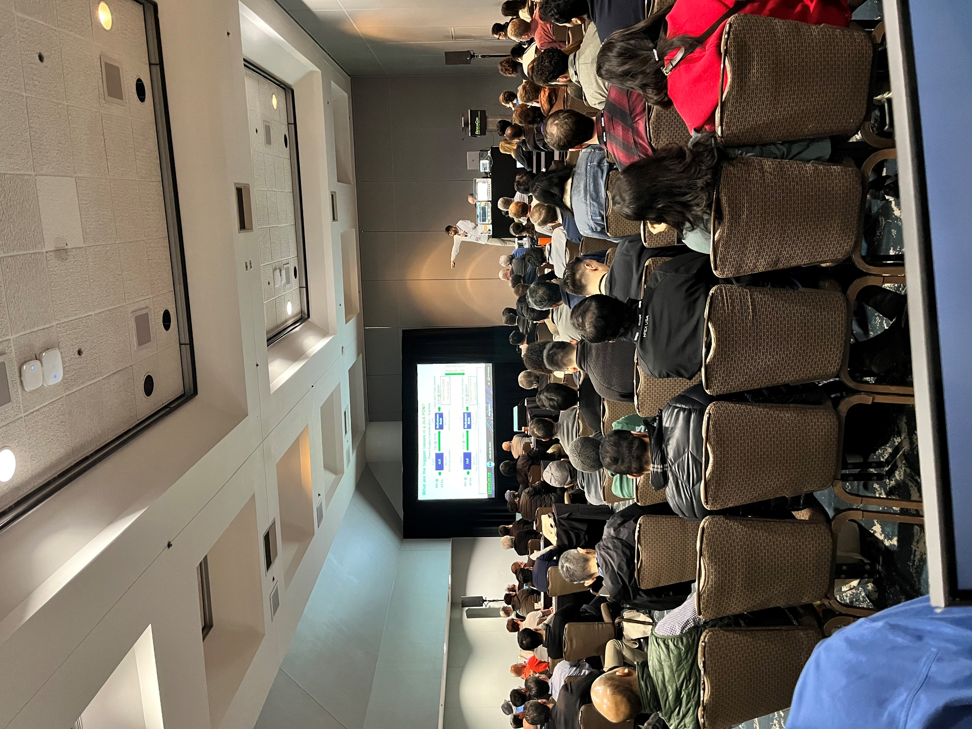
Technical Conference Sessions
Samtec engineers will be participating as authors and/or speakers in papers, panels, and sponsored sessions throughout the conference.
Wednesday
8:00-8:45: Paper: Improving Spectral Efficiency by Optimizing Sub-Nyquist Equalization for 448 Gbps, Brandon Gore, Andrew Josephson, Rich Mellitz, Samtec et al.
12:10-12:50: Sponsored Session: Successful PCIe 6.0 & 7.0 System Guidelines, Steve Krooswyk, Samtec.
12:15-1:00: Paper: Distributed Capacitor Characterization for Advanced Packaging, Istvan Novak, Samtec, et al.
3:00-3:45: Paper: An Improved Broadband Material Characterization Method, Leon Wu and Mick Zhou, Samtec.
Thursday
2:00-2:45: Expert Discussion: Lessons Learned at 224 Gbps Steve Krooswyk, Liam Parkes, Samtec; John Calvin, Keysight; Todd Bermensolo, Alphawave.
4:00-5:15: Panel: Designing & Validating the Future: SERDES & Channel Innovations for PCIe at 128 GT/s, Steve Krooswyk, Samtec et al.

About Samtec, Inc.
Samtec is a $1 billion global manufacturer of a broad line of electronic interconnect solutions, including High-Speed Board-to-Board, High-Speed Cables, Mid-Board and Panel Optics, Precision RF, Flexible Stacking, and Micro/Rugged components and cables. With 40+ international locations and products sold in more than 125 countries, Samtec’s global presence enables its unmatched customer service. Samtec delivers next-generation, high-quality interconnect solutions for the datacom, telecommunications, computer, semiconductor, medical, industrial, automotive, and instrumentation industries, among others. For more information, please visit: http://www.samtec.com
Samtec, Inc.
P.O. Box 1147
New Albany, IN 47151-1147
USA
Phone: 1-800-SAMTEC-9 (800-726-8329)
www.samtec.com/media-room
Our press team enjoys working with journalists around the world to share compelling and innovative stories. If you are a member of the media/press and would like to talk, please send an email to mediaroom@samtec.com.

