

FOR IMMEDIATE RELEASE
February 2026
CONTACT: Mediaroom@samtec.com

Samtec Interconnects Selected for VITA 90 VNX+
Samtec interconnects selected to improve signal integrity and reduce SWaP of evolving VITA standards requiring miniaturization and functionality advancements.

VITA™ 90 VNX+™ is a new rugged, high-performance small-form-factor standard recently ratified by ANSI and VITA for addressing the robust embedded computing requirements of UAVs, UUVs, missiles, satellites, and cube satellites commonly deployed in industrial, military and aerospace applications. Samtec’s rugged high-density, high-performance interconnects and alignment products were selected for the VITA 90 standard for use on both the plug-in module (PIM) and the backplane enabling a SWaP alternative to 3U OpenVPX. VNX+ modules are a fraction of the size of existing OpenVPX modules.

Suitable for rugged, high reliability system applications, VITA 90 VNX+ adheres to a modular open-system design approach providing system architects a high-performance embedded computing platform for space-constrained, harsh environment applications. The commonality of VNX+ PIM designs encourages interoperability and replaceability, along with design reuse. This is validated through SOSA’s selection of this standard as their approved SFF PIM.

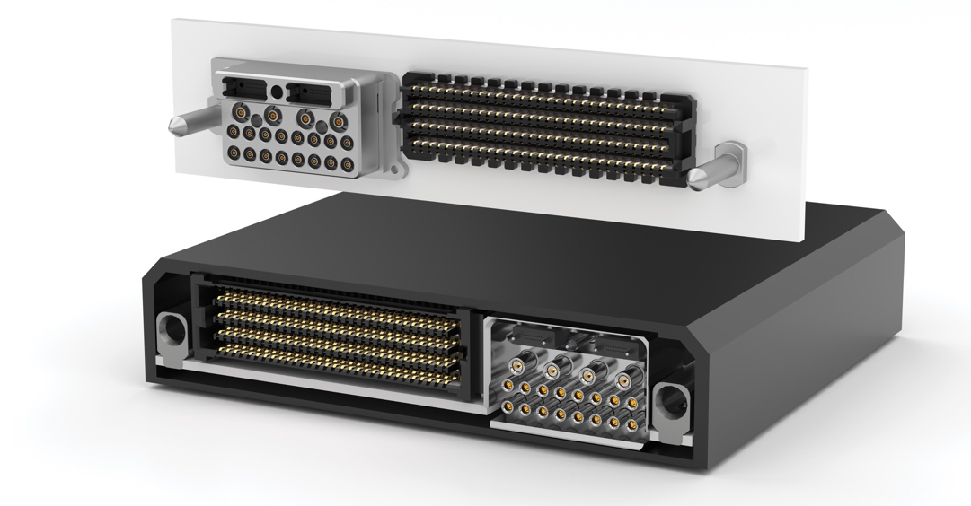

Form Factor & Connector Features
VITA 90 consists of several sub-standards, or dot specifications, each governing different domains of the SFF ecosystem. The base standard (90.0) details requirements for the plug-in module (PIM) and backplane for use in a compact, conduction cooled chassis.

PIMs are approximately 89 x 78 mm in single or double heights. Single-height PIMs are 13 mm or 19 mm tall and double-height PIMs are 27 mm or 39 mm tall. The high-speed data connector (HSDC) within the PIM is Samtec’s SEARAY™ high-speed 56 Gbps, high-density array. Configurations selected for the VITA 90 standard are 4-row and 8-row with 200, 240, 320 or 400 total pins allowing high-density design-in flexibility. The 320-Pin and 240-Pin connector configurations create additional space along the PIM’s connector face, enabling the integration of connector modules.

Connector modules, outlined in VITA 90.2, support specialized contacts for coaxial and optical connections for further enhancing PIM-to-backplane adaptability and functionality. Coaxial contacts (Samtec’s GPCC-20 & GPCC-16 Series) are available with either a 50 Ohm or 75 Ohm characteristic impedance for transmitting Radio Frequency (RF) and/or video signals using a coaxial cable line. Contacts are shrouded to protect from physical damage and foreign objects and debris (FOD), with frequency capabilities from DC to 110 GHz. Optical interfaces are 12 and 24 fiber MT ferrule slots, allowing adoption of any suitable pluggable, rugged optics cable assembly including Samtec’s FireFly™ optical transceivers. Power supply modules, outlined in VITA 90.3, support conduction and liquid cooled environments for higher output applications. Samtec’s SEARAY™ connector was selected for the mating interface due to its open-pin-field versatility and performance.

VNX+ modules are supported by Samtec’s guide hardware. The guidance system has a built-in ground pin for first mate last break capability, which allows a ground to be established prior to connection being made.

Ordering Information
The VITA 90 VNX+ small form factor standard is suitable for rugged, high-reliability embedded computing applications. For more information including interconnect prints and models, or to place an order, visit samtec.com/vnx-plus.

-----------------------------

About Samtec, Inc.
Samtec is a $1 billion global manufacturer of a broad line of electronic interconnect solutions, including High-Speed Board-to-Board, High-Speed Cables, Mid-Board and Panel Optics, Precision RF, Flexible Stacking, and Micro/Rugged components and cables. With 40+ international locations and products sold in more than 125 countries, Samtec’s global presence enables its unmatched customer service. Samtec delivers next-generation, high-quality interconnect solutions for the datacom, industrial, military/aerospace, medical, computer, semiconductor, instrumentation, and automotive industries, among others. For more information, please visit: http://www.samtec.com.

Samtec, Inc.

P.O. Box 1147

New Albany, IN 47151-1147

USA

Phone: 1-800-SAMTEC-9 (800-726-8329)

