

FOR IMMEDIATE RELEASE
May 2026
CONTACT: Mediaroom@samtec.com

Samtec Releases Ultra Micro mPOWER® Connectors with Through-Hole
PCB Termination
Samtec’s ultra micro mPOWER connector system is now available with through-hole PCB termination options for enhanced mechanical strength and reliability in industrial, military, and aerospace applications.

New Albany, IN: Samtec, Inc., the service leader in the connector industry, announces product expansion of its popular mPOWER ultra micro power interconnect system. mPOWER vertical board connectors (UMPS, UMPT) and right-angle board connectors (UMPT-RA) are now available with through-hole board termination options, providing the enhanced mechanical robustness that is often required in harsh industrial, military, and aerospace applications. Connector designs using surface mount technology are also available.

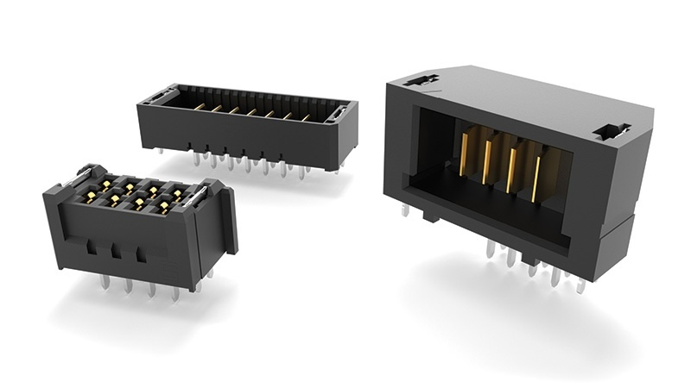

Designed for power density, mPOWER ultra micro connectors offer a 40% space savings over conventional power connectors. Their compact form factor supports up to 18 A per power blade, enabling reliable high current performance without sacrificing board space.

In addition to power density, mPOWER interconnects provide design flexibility across board-to-board, wire-to-board, and wire-to-wire applications. System design is simplified through a range of options, including vertical and right-angle configurations, stack heights from 5 mm to 20 mm, rugged latching features, and 2 to 10 power positions. PVC or Teflon® fluoropolymer cable assemblies are available in multiple wire gauges to support varying application needs.
To simplify the design process, Samtec’s mPOWER connectors are accompanied by free access to design resources such as prints, models, and test reports. Engineers can evaluate power requirements, form and fit at samtec.com/mpower or by contacting Samtec’s Rugged/Power Group at RuggedPower@samtec.com. Full production quantities are available directly from Samtec or through authorized distribution partners.

-----------------------------

About Samtec, Inc.
Samtec is a $1 billion global manufacturer of a broad line of electronic interconnect solutions, including High-Speed Board-to-Board, High-Speed Cables, Mid-Board and Panel Optics, Precision RF, Flexible Stacking, and Micro/Rugged components and cables. With 40+ international locations and products sold in more than 125 countries, Samtec’s global presence enables its unmatched customer service. Samtec delivers next-generation, high-quality interconnect solutions for the datacom, industrial, military/aerospace, medical, computer, semiconductor, instrumentation, and automotive industries, among others. For more information, please visit: http://www.samtec.com.

Samtec, Inc.

P.O. Box 1147

New Albany, IN 47151-1147

USA

Phone: 1-800-SAMTEC-9 (800-726-8329)

