FOR IMMEDIATE RELEASE

CONTACT: mediaroom@samtec.com

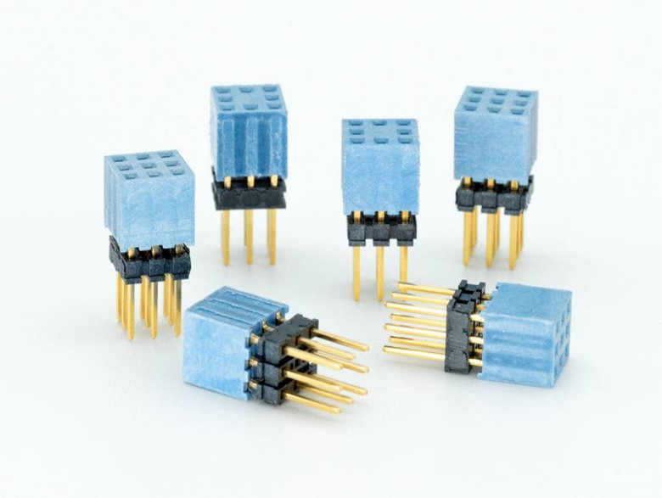
Samtec Connectors Enable Rapid Design of Unmanned Craft
New Albany, IN, June 30, 2026 — Samtec, Inc., the service leader in the connector industry, announces the UxV/35-FleXYZTM ESQT series of durable interconnect systems designed to stack and nest, forming a vertical 35-pin bus that adjusts to different design sizes and configurations. These connectors support the UXV/35 TM standard for small, unmanned craft from the RMS Consortium.
The UxV/35 Standard
The UxV/35 standard supports fast-track, small, unmanned craft designs by providing compatible, open-source flight and vehicle control with snap-together systems and minimal wiring. The standard includes guidance on connector definitions, PCB design/layout, electrical interfaces (pin mapping), stackable bus architecture, power distribution frameworks, and module definitions. Modules can be combined to function in application-specific configurations, such as flight controllers, electronic speed controls (ESCs), power distribution, and communications. Detailed information on the standard can be found at UxV/35 Standard — RMS Consortium.
UxV/35 Durable Interconnect
In collaboration with members of the RMS Consortium, Samtec developed a series of durable interconnect systems, UxV/35-FleXYZTM ESQT, based on a 2 mm grid with a 3×3 pin configuration. Because these connectors stack and nest, they can be used to form a vertical bus that adjusts to different design sizes and configurations. Specifically, the series comprises 9-pin and 8-pin connectors with either long-pin or short-pin configurations. Designers combine three 9-pin connectors with one 8-pin that acts as a keying guide for assembly, creating a 35-pin bus.
To help indicate that they are USA-sourced, the connectors feature a distinctive blue housing. Test reports, including power integrity, severe environmental, and solder heat resistance testing, as well as prints and PADS, files are available on the Samtec product page: UXV/35 Standard Products.
Availability
Well-suited for use in small, unmanned craft, including unmanned ground vehicle (UGV), unmanned surface vehicle (USV; water), and unmanned aerial vehicle (UAV) designs for military or commercial use, the UxV/35-FleXYZ ESQT series is available directly from Samtec or through Samtec’s authorized distribution partners. For more information, contact UxV35@samtec.com.

About Samtec, Inc.

Samtec is a $1 billion global manufacturer of a broad line of electronic interconnect solutions, including High-Speed Board-to-Board, High-Speed Cables, Mid-Board and Panel Optics, Precision RF, Flexible Stacking, and Micro/Rugged components and cables. With 40+ international locations and products sold in more than 125 countries, Samtec’s global presence enables its unmatched customer service. Samtec delivers next-generation, high-quality interconnect solutions for the datacom, telecommunications, computer, semiconductor, medical, industrial, automotive, and instrumentation industries, among others. For more information, please visit: http://www.samtec.com.

Samtec, Inc.
P.O. Box 1147
New Albany, IN 47151-1147
USA
Phone: 1-800-SAMTEC-9 (800-726-8329)
www.samtec.com/media-room

Our press team enjoys working with journalists around the world to share compelling and innovative stories. If you are a member of the media/press and would like to learn more, please email mediaroom@samtec.com.

