

FOR IMMEDIATE RELEASE
CONTACT: mediaroom@samtec.com

Samtec to Exhibit at ECOC 2026, Participate in OIF
Interoperability Demo

See Samtec products in booth #2004 and at the OIF booth #2126/2128 as part of the
OIF Interoperability Demo.

New Albany, IN, Sept. 8, 2026 — Samtec, Inc., the service leader in the connector industry, will be demonstrating next-generation, high-performance optical and copper interconnect solutions in booth #2004 at the upcoming ECOC exhibition (September 21-23 at Trade Fairs and Congress Center of Málaga, Málaga, Spain).
Samtec Networking Solutions in Booth #2004
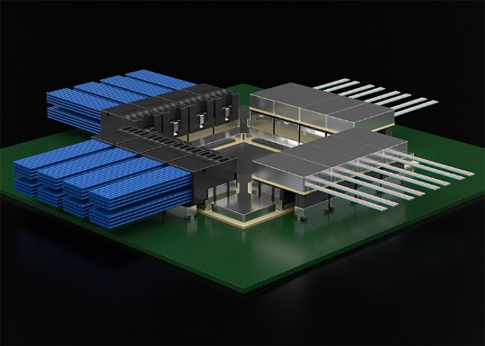
Samtec high-speed interconnects are frequently designed into AI and high-performance computing, medical, test & measurement, and FPGA applications. This year at ECOC, Samtec will showcase demonstrations incorporating Si-Fly® HD CPX Co-Packaged and Near-Chip Systems for optical and copper applications up to 448 Gbps, including silicon and optical engines from multiple partners, and the Bulls Eye® BE130 high-performance test system for 448 Gbps. Samtec will also demonstrate next-gen proofs-of-concept (PoCs) for 448 Gbps connectivity, ideally suited for AI scale-up/scale-out infrastructure implementations and use cases.
OIF Interoperability Demo
On the exhibit floor at ECOC 2026, OIF’s interoperability showcase (booth #2126/2128) serves as a vendor proving ground, translating implementation agreements (IAs) into working, repeatable interoperability so operators can reduce integration risk, maintain sourcing flexibility, and move from innovation to deployment with greater confidence. This year’s demonstrations will feature collaboration from 39 companies in four critical technology areas: Optical Systems; Energy Efficient Interfaces (EEI) & Co-Packaging; Common Electrical I/O (CEI): CEI-448G, CEI-224G; and Common Management Interface Specification (CMIS).
The following Samtec Equipment will feature in CEI and EEI demonstrations with partners:
- A demo chassis for 224 Gbps will include Samtec Si-Fly HD CPX modules (copper and optics), illustrating the validity of the CPX concept and the MSA Architecture
- Samtec BE90 on Bulls Eye ISI board at 224 Gbps
- Samtec BE70 and Nitrowave® high-performance RF microwave cable assemblies LL110 and LL130 running at 224 Gbps
- Samtec Precision RF 1.0 mm and 1.85 mm connectors and adaptors
- Si-Fly HD 448 PAM4 and PAM6 prototypes using 1 m Eye Speed® Hyper Low Skew Twinax.

Samtec’s Si-Fly HD co-packaged and near-chip system is an electrically pluggable co-packaged copper and optics solution, achievable on a 95 x 95 mm or smaller substrate using Samtec's SFCM connector. The SFCM mounts directly to the package substrate and is pluggable with Samtec's SFCC cable assembly or is interoperable with industry-standard optical cable assemblies. Co-packaged connectivity eliminates insertion losses in the BGA breakout and PCB, enabling a complete passive DAC 224G channel that delivers extreme performance at low cost. Samtec is also demonstrating PoC Si-Fly HD 448 Gbps prototypes for PAM4 and PAM6.
Bulls Eye ISI Evaluation Board offers numerous variable-length signal paths with known loss profiles beyond 130 GHz. When combined with a Bulls Eye test assembly, the solution provides a test platform for validating and verifying high-speed SerDes, as well as evaluating and demonstrating 224 Gbps PAM4 and 448 Gbps signal performance.
More Information

- High Performance Active Optics & Passive Optics Solutions
- Si-Fly HD 224 Gbps PAM4, Co-Packaged & Near Chip Systems
- Samtec Precision RF products
- Video demonstration of Samtec’s Si-Fly HD CPX product: Samtec's YouTube Channel
- Contact Samtec’s technical experts at booth #2004 or HDR@samtec.com

About OIF
OIF Brings Industry-Wide Interoperability to Life at ECOC 2026, Accelerating Scalable, Efficient Networks for the AI Era
OIF returns to ECOC 2026 with a live, multi-vendor interoperability demo featuring 39 participating companies. Spanning optical, electrical, energy efficient and management interfaces, the demo highlights interoperability across Optical Systems, 448G & 224G Common Electrical I/O (CEI), CMIS, Co-Packaging, Energy Efficient Interfaces, and more, advancing scalable, efficient AI-era networks. Visit OIF at booth #2126 or learn more at https://www.oiforum.com/meetings-events/oif-ecoc-2026.
About Samtec
Founded in 1976, Samtec is a privately held, $1 billion global manufacturer of a broad line of electronic interconnect solutions, including High-Speed Board-to-Board, High-Speed Cables, Mid-Board and Panel Optics, Precision RF, Flexible Stacking, and Micro/Rugged components and cables. Samtec Technology Centers are dedicated to developing and advancing technologies, strategies, and products to optimize both the performance and cost of a system from the bare die to an interface 100 meters away, and all interconnect points in between. With 40+ international locations and products sold in more than 125 different countries, Samtec’s global presence enables its unmatched customer service. For more information, please visit: http://www.samtec.com
Samtec, Inc.
P.O. Box 1147
New Albany, IN 47151-1147
USA
Phone: + 812-944-6733
www.samtec.com/media-room

Our press team enjoys working with journalists worldwide to share compelling, innovative stories. If you are a member of the media/press and would like to talk, please email mediaroom@samtec.com.

